 

**MODERN MOTORS SERVICE AND PAYROLL MANAGEMENT SYSTEM**

**By**

**SHEETAL.SREEDHAR**

**(Register No – 111918621346)**

Of

**S.A. ENGINEERING COLLEGE, CHENNAI 600077**

**(An Autonomous Institution, Affiliated to Anna University)**

**A PROJECT WORK**

Submitted to the

**FACULTY OF INFORMATION AND COMMUNICATION ENGINEERING**

*In partial fulfillment of the requirements for the award of the degree*

*of*

**MASTER OF COMPUTER APPLICATIONS**

**ANNA UNIVERSITY**

**CHENNAI - 600 025**

**March-2021**

**BONAFIDE CERTIFICATE**

Certified that this project report title “**MODERN MOTORS SERVICE AND PAYROLL MANAGEMENT SYSTEM** ” is the bonafide work of **SHEETAL SREEDHAR** (Register Number: **111918621346**), who carried out the project under my supervision. Certified further, that to the best of my knowledge the work reported herein does not form part of any other project report or dissertation on the basis of which a degree or award was conferred on an earlier occasion on this or any other candidates.

**SUPERVISOR** **HEAD OF THE DEPARTMENT**

# Submitted to Project and Viva Examination held on

Internal Examiner External Examiner

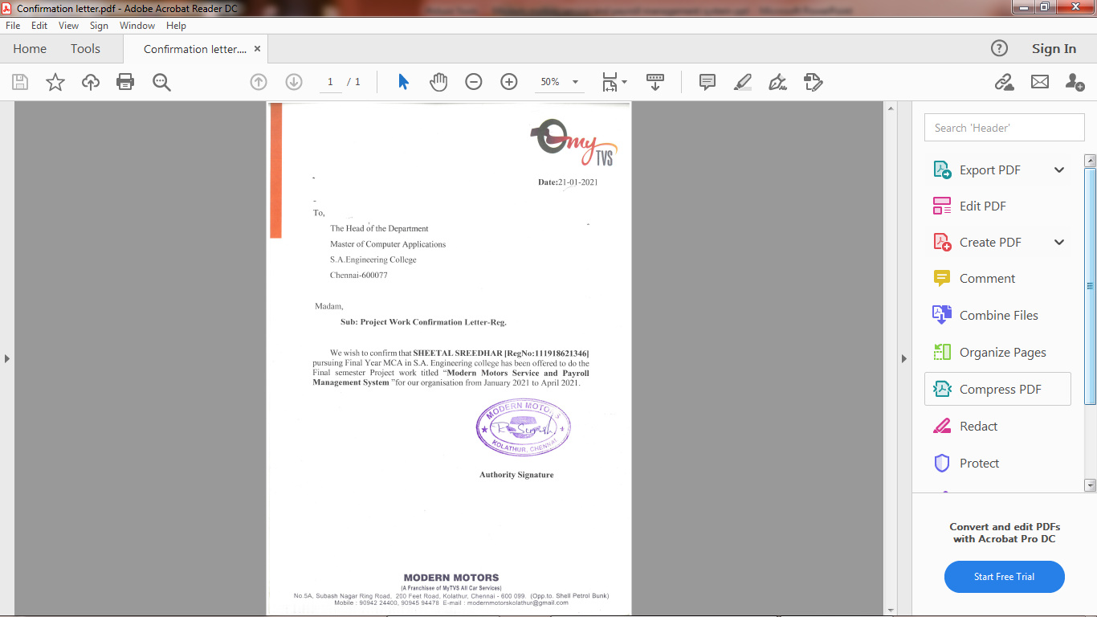

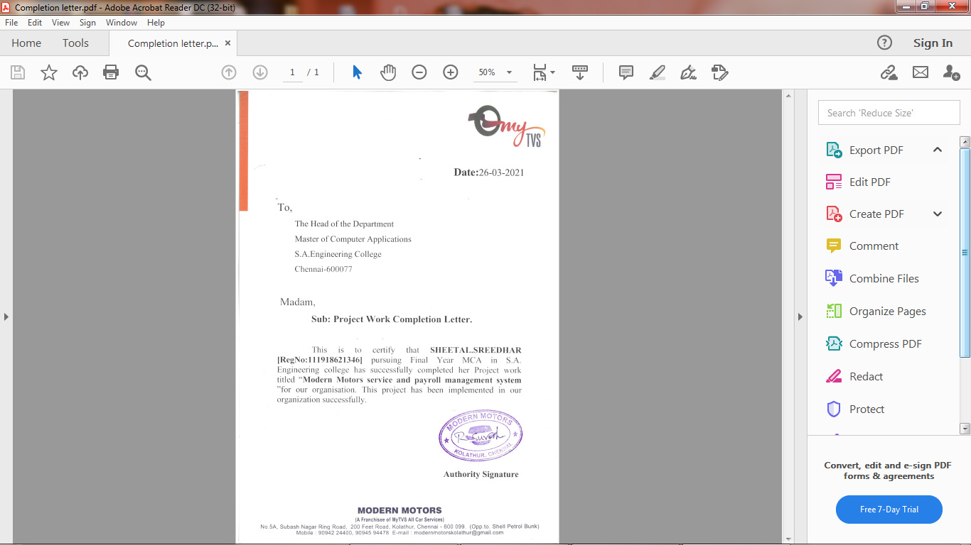

**ACKNOWLEDGEMENT**

I am elated to place in record out most sincere appreciation and thanks to our Founder **Thiru D. SUDHARSHANAM** for providing large facilities for progress.

My sincere and foremost thanks to our honorable Chairman **Thiru D. DURAISAMY** for his sincere endeavor in educating us in his premier institutions.

I express my gratitude to our beloved Director **Mr. D. SABARINATH B.Sc. MBE.,** for this word which inspired us a lot in completing the main project.

I also express my gratitude to our principal **Dr. G.S. KUMARASAMY, M.E., Ph.D.,** who inspired us a lot in completing the project.

I take this opportunity to thank **Mrs.V. SUJATHA, M.C.A., (Ph.D.),** Associate Professor, Head of the Department of Computer Applications, for her cooperation, who has helped me to complete this project.

I am happy to express my sincere thanks to my project internal guide **Mrs.V. SUJATHA, M.C.A., (Ph.D.),** Associate Professor, Head of the Department of Computer Applications, for her constant encouragement and effort taken in directing me in all through my project work.

I am equally thankful to all faculty members of MCA department, family and friends for their endless support throughout the project period.

**SHEETAL.SREEDHAR**

**CONTENTS**

**Title**

Abstract…………………………………………………………………………….....i

List of Tables………………………………………………………………………....ii

List of Figures…….……………………………………………………………….....iii

**I Introduction**

1.1 Organization Profile………………………………….…………………..............01

1.2 Problem Definition……………………………………………………………….02

**II System Analysis**

2.1 Existing System…………………………………………………………………..03

2.2 Proposed System…………………………………………………………………03

**III Development Environment**

3.1 Hardware Requirement…………………………………………………………...05

3.2 Software Requirement……………………………………………………………05

3.2.1 Software Description…………………………………………………………...06

**IV System Design**

4.1 Data Model…………………………………………………………………….....11

4.1.1 Entity Relationship Diagram…………………………………………...12

4.1.2 Data Dictionary………………………………………………………...14

4.1.3 Table Relationship……………………………………………………...21

4.2 Process Model…………………………………………………………………....22

4.2.1 Context Analysis……………………………………………………….22

4.2.2 Data Flow Diagram…………………………………………………….23

**V Software Development**

5.1 Phase of Software Development..………………………………………………..26

5.2 Modular Description……………………………………………………………...27

**VI Testing**

6.1 System Testing………………………………...…………………………………32

6.2 Unit Testing……………………………………………………………................34

6.3 Integration Testing………………………………………………………….........37

6.4 Testing Techniques and strategies…………………………………………….....39

6.5 Validation Testing………………………………………………………………..40

**VII System Implementation**

7.1 Introduction ……………………………………………...…………………........44

7.2 Implementation ……………………………………………...…………………...45

**VIII Performance and Limitations**

8.1 Performance……………………………………………………………………....46

8.2 Limitations………………………………………………………………………..468.3 Future Enhancement………………………………………...……………………46

**IX Appendix**

9.1 Sample screens…………………………………………………………………...47

9.2 Conclusion………………………………………………………………………..55

**X References** .......................……………...……………………………………………56

# ABSTRACT

This Web application provides payroll processing for the employees in which the client can update employee details, salary, Timesheet and attendance . It also provides service at the doorstep for customers after the customer book’s their required service and they are ready to checkout. The customer receives a confirmation email of their service or products after their required purchase. In this website we are selling products of car accessories such ah windshields, mirrors, indicators, lubricants…etc. Each product has their own specific requirements. If the customer wants to cancel the items, the items which they have purchased ,they can cancel their order and cancellation mail is send to the customers to their respective Mail-Id. Therefore if the customer needs any services he/she does not need to go to the shop to take the service, they can comfortably add their required package of service in which they need with the knowledge of their interested date and time. The employees in the shop will provide services to the customers in their place at the particular date and time in which customers have mentioned. The benefits of the application is that the client can easily maintain employee data and can keep a track of the products and their resources. The website provide immense amount of services and products which in need satisfy customers and their expectations.

**LIST OF TABLES**

|  |  |  |  |
| --- | --- | --- | --- |
| **S.NO** | **TABLE NO** | **TABLE NAME** | **PAGE NO** |
| 1 | TABLE 1.1 | Problem statement | 2 |
| 2 | TABLE 3.1 | Hardware Requirements | 5 |
| 3 | TABLE 3.2 | Software Requirements | 6 |
| 4 | TABLE 4.1 | Login details | 15 |
| 5 | TABLE 4.2 | Customer Details | 15 |
| 6 | TABLE 4.3 | Product Details | 16 |
| 7 | TABLE 4.4 | Brand Details | 16 |
| 8 | TABLE 4.5 | Category Details | 16 |
| 9 | TABLE 4.6 | Order Details | 17 |
| 10 | TABLE 4.7 | Service details | 17 |
| 11 | TABLE 4.8 | Payment details | 18 |
| 12 | TABLE 4.9 | Cancellation details | 18 |
| 13 | TABLE 4.10 | Employee details | 19 |
| 14 | TABLE 4.11 | Salary details | 20 |
| 15 | TABLE 6.1 | Unit Testing | 35 |
| 16 | TABLE 6.2 | Integrating Testing | 38 |
| 17 | TABLE 6.3 | Validation Testing | 41 |

**LIST OF FIGURES**

|  |  |  |  |
| --- | --- | --- | --- |
| **S.NO** | **FIGURE NO** | **FIGURE NAME** | **PAGE NO** |
| 1 | Fig. 4.1 | ER Diagram | 13 |
| 2 | Fig. 4.2 | Table Relationship | 22 |
| 3 | Fig. 4.3 | Context Analysis Diagram | 23 |
| 4 | Fig. 4.4 | Level-1 DFD | 24 |
| 5 | Fig. 4.5 | Level-2 DFD | 25 |
| 6 | Fig. 6.1 | Unit Testing | 36 |
| 7 | Fig. 6.2 | Integration Testing | 39 |
| 8 | Fig. 6.3 | Validation Testing | 43 |
| 9 | Fig. 9.1 | Home Page | 47 |
| 10 | Fig. 9.2 | Customer signin and signup page | 47 |
| 11 | Fig. 9.3 | Shopping cart product Page | 48 |
| 12 | Fig. 9.4 | Shopping cart service Page | 48 |
| 13 | Fig. 9.5 | Category Page | 49 |
| 14 | Fig. 9.6 | Subcategory page | 49 |
| 15 | Fig. 9.7 | My Cart Page | 50 |
| 16 | Fig. 9.8 | Order details Page | 50 |
| 17 | Fig. 9.9 | Employee List Page | 51 |
| 18 | Fig. 9.10 | Cash Advance Page | 51 |
| 19 | Fig. 9.11 | Deduction Page | 52 |
| 20 | Fig. 9.12 | Payroll Page | 52 |
| 21 | Fig. 9.13 | Payslip page | 53 |
| 22 | Fig. 9.14 | Timein and Timeout of Employee Page | 53 |
| 23 | Fig. 9.15 | Admin panel Page | 54 |
| 24 | Fig. 9.16 | Payment Page | 54 |

# CHAPTER -I

**INTRODUCTION**

**1.1ORGANIZATION PROFILE**

Modern motors is a mechanical shop in which they provides services and sell products . Modern motors is established in the year of 2013 by Gobumpr in kolathur which is a top layer in the category of car repair and services in the Chennai. This well known establishment acts as a one-stop destination servicing customers both local and other parts of Chennai. Modern motors contains 30 employees who works as a part in the company and provides good services to the customers. The opening time of modern motors is from 9AM in the morning and closing time is 10PM in the midnight. The owners and co-workers in the modern motors have good interaction with the customers. This web application is mainly used for submitting and retrieving the data from the database. This application provides payroll processing for the customers by collecting the details of the employees and storing it. The employee salary and their attendance sheet is maintained. This application provides services for the customers in their requested date and time. This application also sells products in car accessories such as universal parts. The benefits of the application is that the client can easily maintain employee data and can keep a track of the products and their resources. Therefore if the customer needs any services he/she does not need to go to the shop to take the service, they can comfortably add their required package of service in which they need with the knowledge of their interested date and time. The employees in the shop will provide services to the customers in their place at the particular date and time in which customers have mentioned. If the customer has any queries they can write their complaints in the contact us form in which we have provided in the website and the admin will reach them as soon as possible. The website provide immense amount of services and products which in need satisfy customers and their expectations. The web application shows a tremendous growth in day-to-day life. The customer receives a confirmation email of their service or products after their required purchase. In this website we are selling products of car accessories such ah windshields, mirrors, indicators, lubricants…etc. Each product has their own specific requirements. If the customer wants to cancel the items, the items which they have purchased ,they can cancel their order and cancellation mail is send to the customers to their respective Mail-Id.

**1.2 PROBLEM DEFINITION**

The main aim of the project is that the customers can view the products and services and can order their required items and the ordered items can be viewed by the admin. After the customer place their order they will receive a confirmation email.

**Table 1.1:Problem statement**

**Problem statement:**

|  |  |
| --- | --- |
| The problem is | The customers needs to go to the shop to buy any products or to book any services which is very difficult |
| Affects | Customers |
| The impact | Increase the manual work for customers which is time consuming |
| A successful solution would be | Computes the manual work and try to reduce those manual work for customers |

# CHAPTER – II

**SYSTEM ANALYSIS**

Analysis is a delivered study of the various operations performed by the system and their relationship within the system and outside the system. System analysis may be considered as an interface between actual problem and computer. It is management technique used in designing a new system or application.

# 2.1 Existing System

In Modern motors if a customer needs a service he/she needs to go to a shop. The customer details is not maintained properly, all details are maintained in a paper sheet. Efficient amount of time is taken to maintain the accuracy of data. The employee details and their salary wages is maintained in a book which is not preserved in an accurate manner.

**Disadvantages**

* Manual entry
* Time consuming
* Time delay in response

# 2.2 Proposed System

* Provides stock inventory in car accessories such as Filters, Tyres, lubricants…etc.
* This website also provides payroll processing for the employees.
* Provides services for the customer such as:-
* Periodic services
* Denting and painting
* Car spa and cleaning
* Batteries
* Detailing services
* Tyres and wheels
* Builds stronger relationship with the customers.
* An email is sent to the customers after purchasing their items.
* No time delay in response i.e if the customer wants to know any details of the products or services , they can ask any queries in contact us form.
* Cash on delivery is available for the customers after purchasing their products.
* If the customer cancel their products ,a cancellation email is send to their perspective mail-id.

**Advantages:**

* Cost effective and time saving.
* The services are given at the doorstep so the customers no need to go to the shop

# CHAPTER – III

**DEVELOPMENT ENVIRONMENT**

The Development Environment comprises of hardware requirements and software requirements. The Hardware requirement consists of Processor, Hard Disk, Mouse, RAM and Keyboard. The Software requirement consists of Operating System, Front end tool, Back end tool and coding language.

# 3.1 Hardware Requirements

Processor and RAM play a vital role in hardware process. For the development of this application, the following hardware requirements have been considered.

# TABLE: 3.1 Hardware Requirements

**Hardware Requirements**

|  |  |
| --- | --- |
| **Processor** | Intel Core i3 |
| **Hard drive** | 32 GB minimum; 64 GB recommended |
| **RAM** | 2 GB RAM minimum; 4 GB RAM recommended |
| **Screen Resolution** | 1280X800 (minimum) |

**3.2 Software Requirements**

Operating System is the major part of software requirements. The Front End Tool and Back End Tool are used for storing and retrieving the information. The Coding Language is most important in developing the application. For the development of this application, the following software requirements have been considered.

# TABLE: 3.2 Software Requirements

**Software requirement**

|  |  |
| --- | --- |
| **Operating System** | Windows 7/8/10 (32 bit or 64 bit) |
| **Front End Tool** | Notepad++ |
| **Coding Language** | HTML,CSS,JAVA SCRIPT |
| **Back End Tool** | XAMPP, MySql |
| **Intermediate Language** | PHP |
| **Web browser** | Google chrome (or) fire fox |

**3.2.1 Software Description**

**Front End:**

**Notepad++** is a [text](https://en.wikipedia.org/wiki/Text_editor) and [source code editor](https://en.wikipedia.org/wiki/Source_code_editor) for use with [Microsoft Windows](https://en.wikipedia.org/wiki/Microsoft_Windows). It supports [tabbed](https://en.wikipedia.org/wiki/Tab_(GUI)) editing, which allows working with multiple open files in a single window. The project's name comes from the [C](https://en.wikipedia.org/wiki/C_(programming_language)) [increment operator.](https://en.wikipedia.org/wiki/Increment_operator)

Notepad++ is distributed as [free software](https://en.wikipedia.org/wiki/Free_software). At first the project was hosted on [SourceForge.net,](https://en.wikipedia.org/wiki/SourceForge.net) from where it has been downloaded over 28 million times, and twice won the SourceForge Community Choice Award for Best Developer Tool. The project was hosted on [TuxFamily](https://en.wikipedia.org/w/index.php?title=TuxFamily&amp;action=edit&amp;redlink=1) from 2010 to 2015; since 2015 Notepad++ has been hosted on [GitHub](https://en.wikipedia.org/wiki/GitHub). Notepad++ uses the [Scintilla editor component](https://en.wikipedia.org/wiki/Scintilla_(software)).

# Features

Notepad++ is [a source code editor.](https://en.wikipedia.org/wiki/Source_code_editor) It features [syntax highlighting](https://en.wikipedia.org/wiki/Syntax_highlighting), [code folding](https://en.wikipedia.org/wiki/Code_folding) and limited [autocompletion](https://en.wikipedia.org/wiki/Autocompletion) for [programming](https://en.wikipedia.org/wiki/Programming_language), [scripting](https://en.wikipedia.org/wiki/Scripting_language), and [markup languages](https://en.wikipedia.org/wiki/Markup_language), but not [intelligent](https://en.wikipedia.org/wiki/Intelligent_code_completion) [code completion](https://en.wikipedia.org/wiki/Intelligent_code_completion) or syntax checking. As such, it may properly highlight code written in a supported schema, but whether the syntax is internally sound or compilable, cannot be verified. As of version 7.6.3, Notepad++ can highlight the elements of 78 syntaxes:

Notepad++ has features for consuming and creating cross-platform plain text files. It recognizes three [newline representations](https://en.wikipedia.org/wiki/Newline#Representations) (CR, CR+LF and LF) and can convert between them on the fly. In addition, it supports reinterpreting plain text files in various [character encodings](https://en.wikipedia.org/wiki/Character_encoding) and can convert them to [ASCII,](https://en.wikipedia.org/wiki/ASCII) [UTF-8](https://en.wikipedia.org/wiki/UTF-8) or [UCS-2.](https://en.wikipedia.org/wiki/UCS-2) As such, it can fix plain text that seem gibberish only because [their character encoding is not properly detected.](https://en.wikipedia.org/wiki/Bush_hid_the_facts)

Notepad++ also has features that improve plain text editing experience in general, such as:

* + - Auto save
    - Finding and replacing strings of text with [regular expressions](https://en.wikipedia.org/wiki/Regular_expression)
    - Guided indentation
    - Line bookmarking
    - Macro
    - [Simultaneous editing](https://en.wikipedia.org/wiki/Simultaneous_editing)
    - [Split screen](https://en.wikipedia.org/wiki/Split_screen_(computer_graphics)) editing and synchronized scrolling
    - Line operations, including sorting, case conversion (Uppercase, lowercase, camel case, sentence case), and removal of redundant whitespace
    - [Tabbed document interface.](https://en.wikipedia.org/wiki/Tabbed_document_interface)

# Plugins:

Notepad++ has support for [macros](https://en.wikipedia.org/wiki/Macro_(computer_science)) and [plugins](https://en.wikipedia.org/wiki/Plug-in_(computing)), and has been marked for its robust plugin architecture which enabled various new features to be integrated into the program. Currently, over 140 compatible plugins are developed for Notepad++, 10 of which are included by default in the program.The first plugin to be included in the program was *"*TextFX*"*, which includes W3C validation for HTML and CSS, text sorting, character case alteration and quote handling.

# Internalization:

Notepad++ supports internationalization through XML files in an application-specific format containing all internationalized strings (dialog captions, menu titles and items, etc.) in a certain language; this file can be reloaded from the application settings. Translations to new languages can thus be written by simply editing an existing file.

**Back End:**

**XAMPP:**

XAMPP is open source software developed by Apache friends. The use of XAMPP is to test the clients or your website before uploading it to the remote web server. This XAMPP server software gives you the suitable environment for testing MYSQL, PHP, Apache and Perl projects on the local computer.

The full form of XAMPP stands for Cross-platform, Apache, MariaDB (MySQL), PHP and Perl. It is one of the simplest and light-weight local servers that is used to test your website locally. It is an open source platform. This includes X-OS because it works in all major operating systems like Windows, Linux, Mac etc., No configuration is necessary to integrate Php with MySQL.

**PHP:**

PHP is a script language and interpreter that is freely available and used primarily on Linux Web servers. PHP is originally derived from Personal Home Page Tools, now stands for **PHP**: “**Hypertext Pre-processor**”, which the PHP FAQ describes as a "recursive acronym."

**The PHP Hypertext Preprocessor (PHP)** is a programming language that allows web developers to create dynamic content that interacts with databases. PHP is basically used for developing web based software applications. This tutorial helps you to build your base with PHP.

PHP started out as a small open source project that evolved as more and more people found out how useful it was. Rasmus Lerdorf unleashed the first version of PHP way back in 1994. PHP is a MUST for students and working professionals to become a great Software Engineer specially when they are working in Web Development Domain. I will list down some of the key advantages of learning PHP is a recursive acronym for "PHP: Hypertext Preprocessor".

**Common uses of PHP**

* + - PHP performs system functions, i.e. from files on a system it can create, open, read, write, and close them.
    - PHP can handle forms, i.e. gather data from files, save data to a file, through email you can send data, return data to the user.
    - You add, delete, and modify elements within your database through PHP.
    - Access cookies variables and set cookies.
    - Using PHP, you can restrict users to access some pages of your website.
    - It can encrypt data.

**Characteristics of PHP**

Five important characteristics make PHP's practical nature possible −

* + - Simplicity
    - Efficiency
    - Security
    - Flexibility
    - Familiarity

# Structured Query Language (SQL)

To work with data in a database, you must use a set of commands and statements (language) defined by the DBMS software. There are several different languages that can be used with relational databases; the most common is SQL. Both the American National Standards Institute (ANSI) and the International Standards Organization (ISO) have defined standards for SQL. Most modern DBMS products support the Entry Level of SQL-92, the latest SQL standard (published in 1992).

# MySQL Workbench:

MySQL Workbench is the official integrated environment for MySQL. It was developed by MySQL AB, and enables users to graphically administer MySQL database and visually design database structures. MySQL Workbench replaces the previous package of software, MySQL GUI tools. Similar to other third-party packages, but still considered the authoritative MySQL front end; MySQL Workbench lets users manage database design & modelling, SQL development (replacing MySQL Query Browser) and Database administration (replacing MySQL Administrator).

MySQL Workbench is available in two editions, the regular [free and open](https://en.wikipedia.org/wiki/Free_and_open_source_software) [source](https://en.wikipedia.org/wiki/Free_and_open_source_software) Community Edition which may be downloaded from the MySQL website, and the proprietary Standard Edition which extends and improves the feature set of the Community Edition.

# SQL Server Features

Microsoft SQL Server supports a set of features that result in the following benefits:

# Ease of installation, deployment, and use

SQL Server includes a set of administrative and development tools that improve your ability to install, deploy, manage, and use SQL Server across several sites.

# Scalability

The same database engine can be used across platforms ranging from laptop computers running Microsoft Windows® 95/98 to large, multiprocessor servers running Microsoft Windows NT®, Enterprise Edition.

# DATABASE:

A database in Microsoft SQL Server consists of a collection of tables that contain data, and other objects, such as views, indexes, stored procedures, and triggers, defined to support activities performed with the data. The data stored in a database is usually related to a particular subject or process, such as inventory information for a manufacturing warehouse.

SQL Server can support many databases, and each database can store either interrelated data or data unrelated to that in the other databases. For example, a server can have one database that stores personnel data and another that stores product-related data. Alternatively, one database can store current customer order data, and another; related database can store historical customer orders that are used for yearly reporting. Before you create a database, it is Important to understand the parts of a database and how to design these parts to ensure that the database performs well after it is implemented.

**CHAPTER – IV**

**SYSTEM DESIGN**

**4.1 Data Model**

Data Model is a set of concepts to describe the structure of the database and certain constraints that the database should obey. The main aim of data model is to support the development of information system by providing the definition and format of data. A data model can be a diagram or flowchart that illustrates the relationships between data. Usually data models are specified in a data modeling language. Although capturing all the possible relationships in a data model can be very time intensive, it’s an important step and shouldn’t be rushed. Well documented models allow stake holders to identify errors and make changes before any programming code has been written. Data modelers often use multiple models to view the same data and ensure that all processes, entities, relationships, and data flows have been identified. Data Model can be classified into various evolutions. Some of the evolutions are Hierarchical Model, Network Model, Relational Model, Entity Relationship Model and Object Oriented Model.

The structural part of a data model theory refers to the collection of data structures which make up a data when it is being created. These data structures represent entities and objects in a database model. The manipulation part of a data model refers to the collection of operators which be applied to the data structures.

# Role of Data Model

The main aim of data model is to support the development information system by providing the definition and format of data. If this is done consistently across systems then compatibility of data can be achieved. If the same data structures are used to store and access data then different applications can share data. Data model is based on data, data relationship, data semantic and data constraint. A data model provides the details of information to be stored, and is of primary use when the final product is the generation of computer software code for an application or the preparation of a functional specification to aid computer software make or buy decision.

# Categories of Data Model:

* + 1. Conceptual Data Model
    2. Physical Data Model
    3. Implementation Data Model

**Conceptual Data Model:** This data model provides the concept that is close to the way many users perceive data.

**Physical Data Model:** This data model provides the concept that describes the details of how data is stored in the computer.

**Implementation Data Model:** This data model provides the concept that fall between the above two, balancing user views with some computer storage details.

# 4.1.1 Entity Relationship Diagram

**ER Diagram:**

Entity Relationship Diagram (ERD) is a graphical representation of entities and their relationships in a database structure. Entity is mapped to a relational table. Entity set is a collection like entities. The relationship between two strong entities is set shown by using a diamond symbol. “E-R diagram are used to organize data as a relation, normalizing relations and finally obtaining a relational database model”.

Elements of an E-R diagram are:

* + - 1. **ENTITY:** This specifies the real life objects & is represented as:
      2. **RELATIONSHIPS:** This connects entities & establish meaningful dependencies between them & are represented by:
      3. **ATTRIBUTES*:*** This specifies the properties of entities & are represented by:
      4. **COMPOSITE ATTRIBUTES:** This specifies more than one simple attributes & are represented by:

The Entity-Relationship Diagram depicts a relationship between data objects. The ERD is the notation that is used to conduct the data modeling activity. The attributes of each object noted in the ERD can be described using a data object description.

At first a set of primary components are identified for ERD i.e. Data objects, Attributes, Relationships and Various type indicators. Data objects are represented by labeled rectangles. Relationships are indicated with labeled lines connecting objects with diamond symbol. Data modeling and the Entity-Relationship diagram provide the analyst with a concise notation for examining data within the context of data processing application.

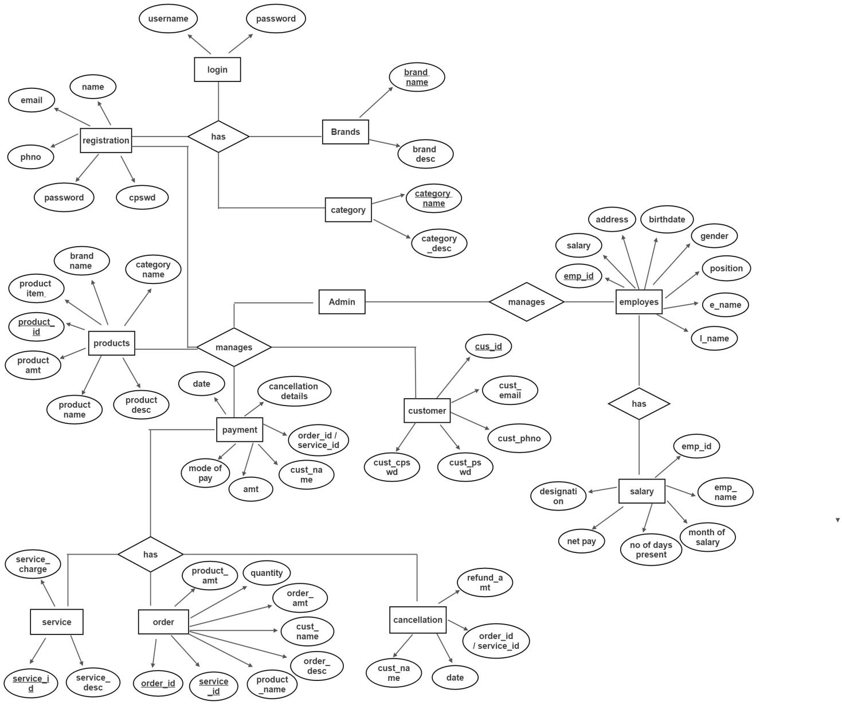

# Fig. 4.1 ER Diagram

**4.1.2 Data Dictionary**

A data dictionary or metadata repository, as defined in the IBM Dictionary of computing, is a “centralized repository of information about data such as meaning, relationships to other data, origin, usage, and format. Data base design is concerned with the data focus from the perspective of the system designer. The end product is called a **database schema**, a technical blueprint of database. Database design translates the data models that were developed for the system users during the definition phase in to data structures supported by the chosen database technology.

The goals of database design are as follows.

* A database should provide for the efficient storage, update and retrieval of data.
* The technique used to improve a data model in preparation for database design is called data analysis.
* Data analysis is a process that prepares a data model for implementation as a simple, non-redundant, flexible and adaptable database.
* The specific technique is called NORMALIZATION.

# Normalization:

Normalization is a technique that organizes data attributes such that they are grouped to form stable, flexible and adaptive entities. It is a process of decomposing unsatisfactory “bad” relations by breaking up their attributes into smaller relations. Normalization of relation schema is done to eliminate insertion and deletion anomalies that exist in databases. Normalization is step-by-step reversible process of converting given collection of relations have a progressively simpler and regular structure.

* To make it feasible to represent any relation in the database.
* To obtain powerful retrieval algorithms based on a simpler collection of relational operations.
* To free relations from undesirable insertions, update and deletion dependencies.
* A relation R is said to be in 1 NF if the attributes whose values for an individual tuples are non-atomic.

A relation R is said to be in 2NF if and only if it is in 1 NF and uses the concept of functional dependencies and primary key.

* A relation R is said to be in 3 NF if it is in 2 NF and it derives the transitive functional dependencies on its primary key.

**Database Tables:**

The tables involved in inspection process along with attribute name, data type, field size, constraint and description about the fields that are stated in the below mentioned table.

# TABLE: 4.1 Login Table

**Login table :**

|  |  |  |  |  |
| --- | --- | --- | --- | --- |
| **Field name** | **Datatype** | **Field size** | **Constraint** | **Description** |
| Username | Varchar | 20 | Not null | Username used by customers |
| Password | Varchar | 20 | Not null | password used by customers |

**TABLE: 4.2 Customer Table**

**Customer details**

|  |  |  |  |  |
| --- | --- | --- | --- | --- |
| **Field name** | **Datatype** | **Field size** | **Constraint** | **Description** |
| Cust_Id | Int | 10 | Primary key | Id of the customer |
| Cust_name | Varchar | 10 | Primary key | Name of the customer |
| Cust_email | Varchar | 30 | Not null | Email of the customer |
| Cust_phno | Varchar | 10 | Not null | Phone number of the customer |
| Cust_pswd | Varchar | 10 | Not null | Password of the customer |
| Cust_cpswd | Varchar | 10 | Not null | Confirm password of the customer |

**TABLE: 4.3 Product Table**

**Product details**

|  |  |  |  |  |
| --- | --- | --- | --- | --- |
| **Field name** | **Datatype** | **Field size** | **Constraint** | **Description** |
| Product_id | Int | 10 | Primary key | Id of the Product |
| Category name | Varchar | 20 | Foreign key | Name of the product category |
| Brand name | Varchar | 20 | Foreign key | Brand name of the product |
| Product name | Varchar | 10 | Not null | Name of the product |
| Product amt | Int | 30 | Not null | Amount of the product |
| Product items | Varchar | 20 | Not null | Items of the product |
| Product desc | Varchar | 50 | Not null | Description of the product |

**TABLE: 4.4 Brand Table**

**Brand details**

|  |  |  |  |  |
| --- | --- | --- | --- | --- |
| **Field name** | **Datatype** | **Field size** | **Constraint** | **Description** |
| Brand name | varchar | 10 | Primary key | Name of the brand |
| Brand desc | varchar | 50 | Not null | Description of the brand |

**TABLE: 4.5 Category Table**

|  |  |  |  |  |
| --- | --- | --- | --- | --- |
| **Field name** | **Datatype** | **Field size** | **Constraint** | **Description** |
| Category  name | varchar | 10 | Primary key | Name of the category |
| Category  desc | varchar | 50 | Not null | Description of the  category |

**Category details**

**TABLE: 4.6 Order details Table**

**Order details**

|  |  |  |  |  |
| --- | --- | --- | --- | --- |
| **Field name** | **Datatype** | **Field size** | **Constraint** | **Description** |
| Order_id | Int | 10 | Primary key | Id of the order |
| Service_id | Int | 10 | Primary key | Id of the service |
| Product_name | Varchar | 10 | Not null | Name of the product |
| Product_amt | Varchar | 50 | Not null | Amt of the product |
| Quantity | Int | 10 | Not null | Quantity of products |
| Order_amt | Int | 10 | Not null | Amount of the order |
| Cust_name | Varchar | 10 | Not null | Name of the customer |
| Order_desc | Varchar | 50 | Not null | Description of the order |

**TABLE: 4.7 Service details Table**

**Service details**

|  |  |  |  |  |
| --- | --- | --- | --- | --- |
| **Field name** | **Datatype** | **Field size** | **Constraint** | **Description** |
| Service_id | Int | 10 | Not null | Id of the service |
| Service_desc | Varchar | 50 | Not null | Description of the  service |
| Service_charge | Int | 10 | Not null | Amount to be payed for the service |

**TABLE: 4.8 Payment details Table**

**Payment details**

**TABLE: 4.9 Cancellation details Table**

|  |  |  |  |  |
| --- | --- | --- | --- | --- |
| **Field name** | **Datatype** | **Field size** | **Constraint** | **Description** |
| Order_id/  Service_id | Int | 10 | Foreign key | The id of the order |
| Cust_name | Varchar | 10 | Foreign key | Name of the customer |
| Amount | Int | 20 | Not null | Amount to be payed by  the customer |
| Mode of  pay | Varchar | 10 | Not null | Mode of payment |
| Date | date | 10 | Not null | Date of payment |

**Cancellation details**

|  |  |  |  |  |
| --- | --- | --- | --- | --- |
| **Field name** | **Datatype** | **Field size** | **Constraint** | **Description** |
| Order_id**/**  Service_id | Int | 10 | Foreign key | The id of the order |
| Cust_name | Varchar | 10 | Foreign key | Name of the customer |
| Date | date | 10 | Not null | Date of payment |
| Refund  Amount | Int | 20 | Not null | Amount to be  refunded |

**TABLE: 4.10 Employee details for Payroll process Table**

**Employee details for Payroll process**

|  |  |  |  |  |
| --- | --- | --- | --- | --- |
| **Field name** | **Datatype** | **Field size** | **Constraint** | **Description** |
| Emp_id | Int | 10 | Primary key | Id of the employee |
| First_name | Varchar | 10 | Not null | First name of the  employee |
| Last_name | Varchar | 10 | Not null | Last name of the  employee |
| DOB | Date | 10 | Not null | Date of birth |
| Address | Varchar | 30 | Not null | Present Address of the  employee |
| Gender | Varchar | 10 | Not null | Gender of the employee |
| Position | Varchar | 10 | Not null | Position mentioned for  theemployee |
| Schedule | Varchar | 10 | Not null | Schedule of the  employee |
| Salary | Int | 20 | Not null | Salary of the employees |

**TABLE: 4.11 Salary details of Employee Table**

**Salary details of Employee**

|  |  |  |  |  |
| --- | --- | --- | --- | --- |
| **Field name** | **Datatype** | **Field size** | **Constraint** | **Description** |
| Emp_id | Int | 10 | Foreign key | Id of the employee |
| Emp_name | Varchar | 10 | Not null | Name of the employee |
| Designation | Varchar | 10 | Not null | Designation of the employee |
| Net pay | Int | 20 | Not null | How much of the amount taken  divided by 30 |
| Month of  salary | Int | 20 | Not null | Month the salary is distributed |
| No of days  present | Int | 30 | Not null | No of days present by the employee |

**4.1.3 Table Relationship**

A relationship, in the context of databases, is a situation that exists between two relational database tables when one table has a foreign key that references the primary key of the other table. A table relationship works by matching data in key columns-usually columns with the same in both tables. In most cases, the relationship matches the primary key from one table, which provides a unique identifier for each row, with an entry in the foreign key in the other table. Relationships between tables in a database diagram shows how the columns in the table are linked to other columns in another table.

A relationship works by matching data in key columns with same name in both tables. The table matches the primary key from one relationship to other relationship. Each and every table consists of a primary key and foreign key in which the relationship is being created and designed.

A high level of creating a table relationship is a logical object model of the system which will be transformed into a physical model for covering all system entities.

The table relationship can be used by the designer to communicate he design to the end user and the model of the relationship can be design plan by the database to implement a data model specifically management of the software.

# PRIMARY KEY:

A primary key is a key in a relational database that is unique for each record. It is a unique identifier. It must contain a unique value for each row of data. It cannot contain null values. A primary key is a specific choice of a minimal set of attributes that uniquely specify a tuples in a relation. When multiple fields are used as a primary key, they are called a composite key.

# FOREIGN KEY:

A foreign key is a column or group of columns in a relational database table that provides a link between data in two tables. It acts as a cross-reference between tables because it references the primary *key* of another table, thereby establishing a link between them.

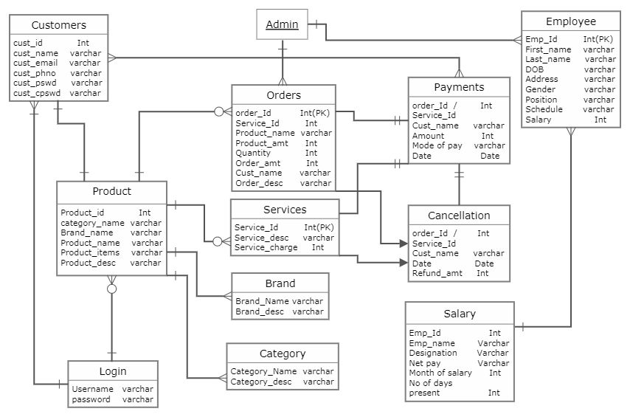

# Fig. 4.2 Table Relationship

**4.2 Process Model**

Process models are processes of the same nature that are classified together into a model. Thus, a process model is a description of a process at the type level. The same process model is used repeatedly for the development of many applications and thus, has many instantiations.

# 4.2.1 Context Analysis Diagram

A context diagram, sometimes called a level 0 data-flow diagram, is drawn in order to define and clarify the boundaries of the software system. It identifies the flows of information between the system and external entities. The entire software system is shown as a single process.

# 

# Fig. 4.3 Context Analysis Diagram

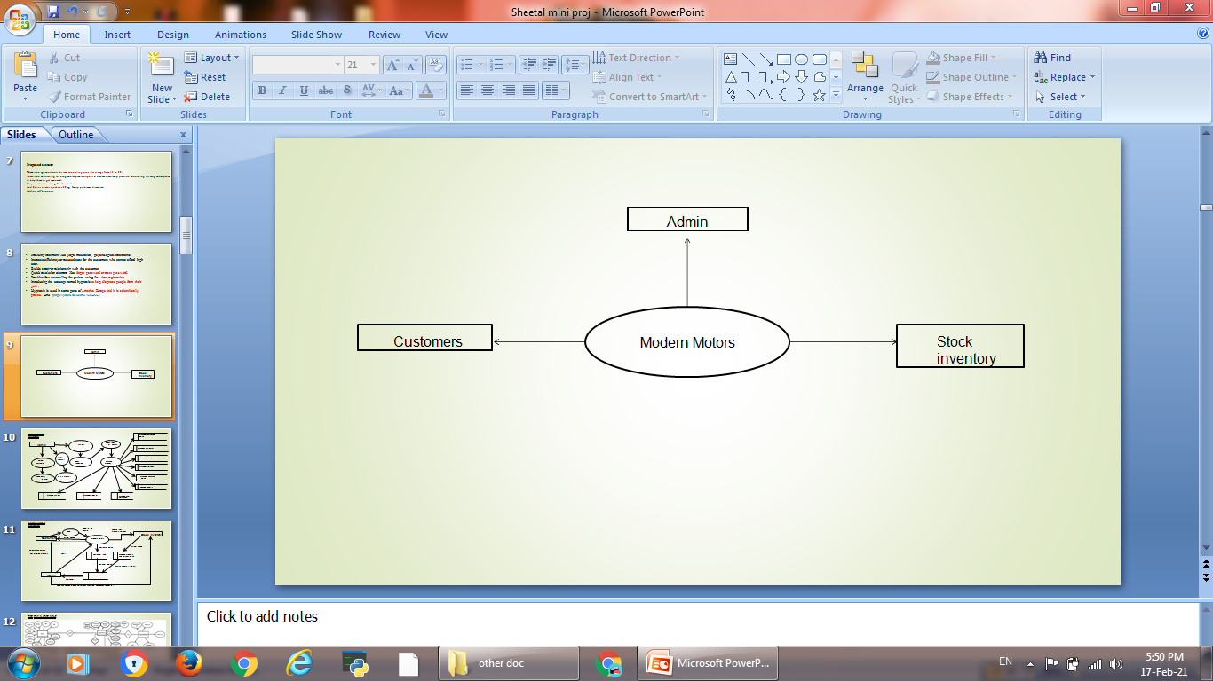**4.2.2 DataFlow Diagram**

A data-flow diagram (DFD) is a way of representing a flow of a data of a process or a system (usually an information system). The DFD also provides information about the outputs and inputs of each entity and the process itself. A data-flow diagram has no control flow. There is no decision rules and no loops. DFD is a graphical representation of the “flow” of data through an information system. DFDs can also be used for the visualization of data processing (structured design).

DFD describes the processes that are involved in a system to transfer *data* from the input to the file storage and reports generation. It uses defined symbols like rectangles, circles and arrows, plus short text labels, to show data inputs, outputs, storage points and the routes between each destination. It depicts the data flow from one step to another.

**Data Flow Diagram Levels:**

There are 3 levels in data flow diagram. They are;

* + - * 0-level DFD
      * 1-level DFD
      * 2-level DFD.

**0-Level DFD:** A context diagram is a top level data flow diagram which is also known as "Level 0". It only contains one process node ("Process 0") that generalizes the function of the entire system in relationship to external entities.

**1-Level DFD:** A level-1 DFD notates each of the main sub-processes that together form the complete system. A level-1 DFD is an “exploded view” of the context diagram.

**2-Level DFD:** A level 2 data flow diagram (DFD) offers a more detailed look at the processes that make up an information system than a level-1 DFD does. It can be used to plan or record the specific makeup of a system.

**Components of Data Flow Diagram:**

The Data Flow Diagrams includes four main component elements. They are entity, process, data store and data flow. External Entity – Also known as actors, sources or sinks, and terminators, external entities produce and consume data that flows between the entity and the system being diagrammed.

# LEVEL 1:

# bandicam 2021-02-17 17-51-08-572.jpg

**Fig. 4.4 Level-1 DFD**

**LEVEL 2:**

# bandicam 2021-03-02 19-53-02-799.jpg

**Fig. 4.5 Level-2 DFD**

**CHAPTER – V**

**SOFTWARE DEVELOPMENT**

Software Development Life Cycle is a process used by software industry to

develop and test high quality software’s. The SDLC aims to produce high quality software that meets or exceeds customer expectations, reaches completion within times and cost estimates. SDLC is a process followed for a software project, within a software organization. It consists of a detailed plan describing how to develop, maintain, replace and alter or enhance specific software. The life cycle defines a methodology for improving the quality of software and the overall development process.

**5.1 Phases of Software Development**

The normal phases of a development project are planning, analysis, design, development, testing, implementation, and enhancement. Different methodologies may call these phases by different names, but they are always present. Each phase has its own products, which may be documents, code, or test results. In DCOII system V-model software development life cycle is followed, which is diagrammatically represented as follows.

# Phase I-Planning

Planning is to generate a high-level view of the intended project and determine the goals of the project. Our project plan depends on the customer needs and their requirements. The first phase will be how much time it will take and how much cost it will take to finish. It plays vital role in developing the software project.

# Phase II-Analysis

The goal of systems analysis is to determine where the problem is in an attempt to fix the system. This step involves breaking down the system in different diagram to analyze the situation. Analyze project goals, break down functions that need to be created, and attempt to engage users so the definite requirements can be defined.

# 

# Phase III-Design

Systems design is the phase where system engineers analyze and understand the business of the proposed system by studying the user requirements document. MHS system design is developed by the hypertext pre-processor based on the user requirements documents. They figure out possibilities and techniques by which the user requirements can be implemented. Software specification document which serves as a blueprint for the development phase is generated.

# Phase IV-Development

Modular and subsystem programming code will be accomplished during this stage. Unit testing and module testing are done in this stage by the MHS develops. Development stage is intermingled with the next in that individual modules will need testing. Goals &targets, of MHS system is achieved by establishing schedules during project development.

# 5.2 Modular Description

The modular description contains full description about every module used in the project. The various modules used in this project are

# Admin module

* + - Customer module
    - Products module
    - Brand module
    - Category module
    - Order details module
    - Service details module
    - Payment module
    - Cancellation module
    - Employee module
    - Salary details module

**Admin module:**

The admin can manage login details. The admin manages user permission and the users whoever logged into the system. He also manages employee details and their daily wages. Manages and track notification system. Manages all the other details(Customer details, employee details...etc)

**Customer module:**

A customer needs to give the registration details such as (name, email, phno, pswd, cpswd).After registering they are asked to login to the website. Then they can purchase or order the required items or services.

**Products module:**

A product module has brand name and category name which is used for creating a product category and inserting the products into it. Each product has its own specifications, price and descriptions. After inserting a product which is done through admin panel , it is asked to upload the images of the products. The products will be displayed in the website with the category name and its descriptions.

**Category module:**

A category module contains category name and description. Each category has also a subcategory which is used for inserting the products.

**Brand module:**

A brand module contains brand name and description. Each brand name represents the product brand and their items.

**Order Details Module:**

After the customer purchase the items their order ID and their order type would be shown in order history. The customer can also track their order with their order ID.

**Service Details Module:**

After the customer purchase for the required service , their service ID would be shown in order history. The customer will receive service at the date and time they have mentioned.

**Payment Module:**

The customer will be directed to Razor-pay after they proceed to checkout their order or service.The customer needs to enter their card details, their email and phone-no. Date of payment will be mentioned.

**Cancellation module:**

If the customer needs to cancel the order or service , they can cancel their order/service underneath the placed order/service which will be mentioned. After the customer cancel their order/service they will receive a Cancellation Mail.

**Employee Module in Payroll process:**

The Employee details will be managed in the admin side. The admin will enter all the employee details. For Each employee an Emp_Id is created. After entering the details employee id will be generated. The employee must enter the employee id in which time they come and in which time they leave. The employee’s salary , deduction, net-pay and gross pay will be calculated. The payroll will be generated after the calculation and then they can take a print of it.

**Salary Details Of Employee:**

For salary details , the employee’s Emp_id, Emp_name and their designation is collected. Net pay is calculated according to the salary which they earn and is lessed by No of days they were not present. Month of salary in which date they have received. No of days they have been present will also be noted.

**CHAPTER - VI**

**TESTING**

Testing is the process or group of procedures carried out to evaluate some aspect of

piece of software. Testing plays a vital role in the success of the system. System testing makes a logical assumption that if all parts of the system are correct, the goal will be successfully achieved. Once program code has been developed, testing begins. The minimum aim of testing process is to identify all defects existing in software product.

Testing establishes the software which has attained a specified degree of quality with respect to selected attributes. The testing process focuses on the logical internals of the software, ensuring that all statements have been tested, and on the functional externals, that is conducted tests to uncover errors and ensure that defined input will procedure actual results that agree with required results. Testing is related with two processes namely **Validation** and **Verification.**

**VALIDATION:** Validation is a process of evaluating a software system or component during or at the end of the development cycle in order to determine whether it satisfies specified requirements. It is usually associated with traditional execution based testing.

**VERIFICATION:** Verification is a process of evaluating a software system or component to determine whether the products of a given development phase satisfy the conditions imposed at the start of that phase. It is associated with activities such as inspection and reviews of the software deliverable.

# Types Of Testing:

* + - Unit Testing
    - Integration Testing
    - System Testing
    - Acceptance Testing

**6.1 System Testing:**

System Testing begins at the requirements phase with the development of a master test plan and requirements-based tests. System Testing is more complicated task. It requires large amount of resources. The goal is to ensure that the system performs according to its requirements. It evaluates both functional behavior and quality requirements such as reliability, usability, performance and security. Testing is one of the important steps in the software development phase.

Testing checks for the errors, as a whole of the project testing involves the following test cases:

* + - Static analysis is used to investigate the structural properties of the source code.
    - Dynamic testing is used to investigate the behavior of the source code by executing the program on the test data.

**Types of System Testing:**

* + - Functional Testing
    - Performance Testing
    - Stress Testing
    - Configuration Testing
    - Security Testing
    - Recovery Testing

**Functional Testing:**

Functional Testing are used to ensure that the behavior of the system to the requirements specification. All functional requirements for the system must be achievable by the system. It focuses on the inputs and proper outputs for each function. Improper and illegal inputs must also be handles by the system. All functions must be tested.

Some of the goals of functional testing are:

* + - All types or classes of legal inputs must be accepted by the software.
    - All classes of illegal inputs must be rejected.
    - All possible classes of the system output must exercised and examined.
    - All functions must be exercised.

**Performance Testing:**

The goal of system performance testing is to see the software meets the performance requirements. Performance Testing allows testers to tune the system; that is to optimize the allocation of system resources. Resources for system testing must be allocated in the system test plan. Results of performance tests are quantifiable. Performance testing requires the test-bed requirement that includes special laboratory equipment and space that must be reserved for the tests.

Test Managers should ascertain the availability of these resources and allocate the necessary time for training in the test plan. Usage requirements for these resources need to be described as part of the test plan.

**Stress Testing:**

When a system is tested with a load that causes it to allocate its resources in maximum amounts, this is called stress testing. Stress testing is most important because it can reveal defects in real-time and other types of systems, as well as weak areas where poor design could unpredictable events may occur resulting in input loads that exceed those described in the requirements documents.

Stress Testing often uncovers race conditions, deadlocks, depletion of resources in unusual or unplanned patterns and upsets in normal operation of the operating system. All these condition are likely to reveal defects and design flaws which may not be revealed under normal testing condition.

**Configuration Testing:**

Configuration Testing allows developers/users to evaluate the system performance and availability when hardware exchanges and reconfiguration occurs. Software system interacts with the hardware devices such as disk drives, tape drives and printers. Many software systems interact with multiple CPUs, some of which are redundant. Software that controls real time processes or embedded software also interfaces with devices but these are very specialized hardware items such as missile launchers and nuclear power device sensors. Several types of operations should be performed during configuration testing.

# Security Testing:

Security testing handles safety and security issues for commercial applications for use on the Internet. The Internet users believe that their personal Information is not secure and is available to those with intent to do harm; the future of e-commerce is in peril. Security testing evaluates system characteristics that relate to the scalability, integrity, and confidentially or system data and services. Damages can be done through various means such as viruses, Trojan horses, trap doors, illicit channels.

Some of the effects that cause Security breaches;

* + Loss of information
  + Corruption of information.
  + Misinformation
  + Privacy violations.
  + Denial of services

# Recovery Testing:

Recovery Testing subjects a system to losses of resources in order to determine if it can recover properly from these losses. Multiple CPUs or multiple instances of devices are used to detect the failure of devices. The recovery testers must ensure that the device monitoring system and the check point software are working properly. It focuses on the process of restart and switchover. It can be detected by loss of transaction, merging of transactions, incorrect transactions and unnecessary duplication of a transaction.

# 6.2 Unit Testing

A unit is the smallest possible testable software component. A unit can be function or procedure implemented in a procedural programming languages. A unit may also be a small-sized COTS component purchased from an outside vendor that is undergoing evaluation by the purchaser, or a simple module retrieved from an in-house reuse library. Unit test results are recorded for future testing process. This result document used for integration and system tests.

Some of the phases for unit test planning are;

* + - * Describe Unit Test Approach and Risks.
      * Identify Unit features to be tested.
      * Add levels of detail to the test plan.

**TABLE: 6.1 Unit Testing**

**Unit Testing**

|  |  |  |  |  |  |
| --- | --- | --- | --- | --- | --- |
| **TEST NO** | **TEST TYPE** | **TEST**  **INPUT** | **EXPECTED**  **OUTPUT** | **ACTUAL OUTPUT** | **RESULT** |
| 1 | Unit Testing | Enter the name in character | The character should be displayed | Displays character | Success |
|  |  | Enter the name in numeric | The character should be displayed | Displays the number | Failure |
| 2 | Unit Testing | Enter the password | The password should display | Displays password | Success |
|  |  | Enter password | The password should display | Mismatch password | Failure |

**TESTCASE SUCCESS:**

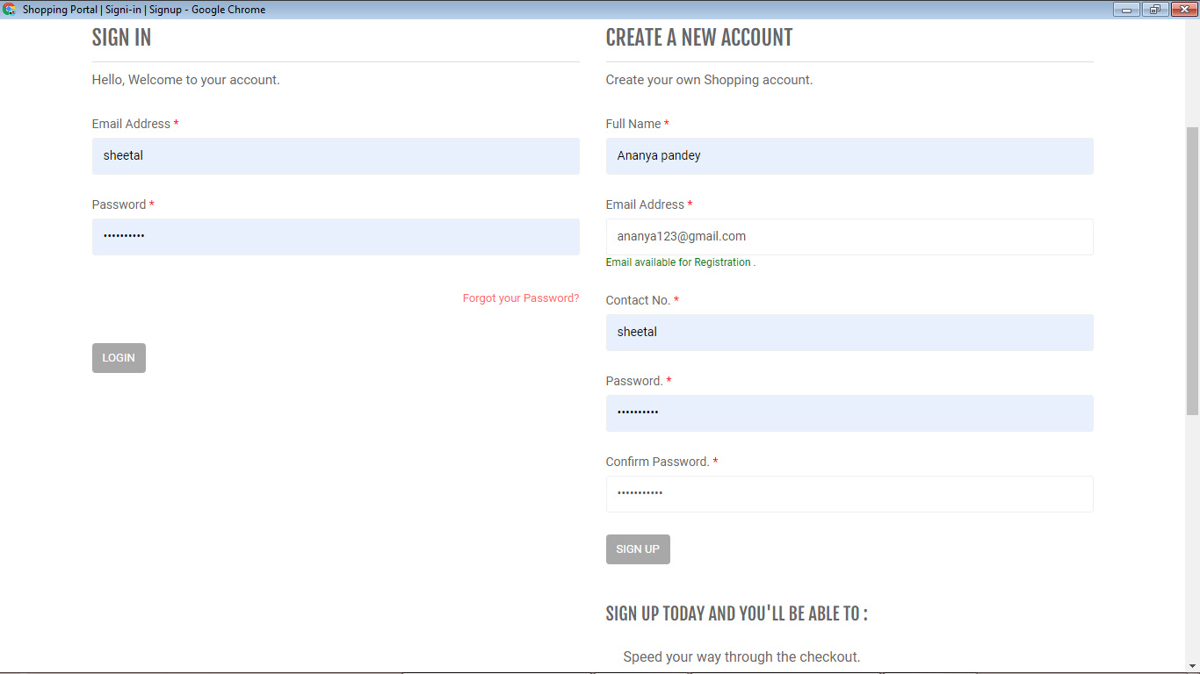

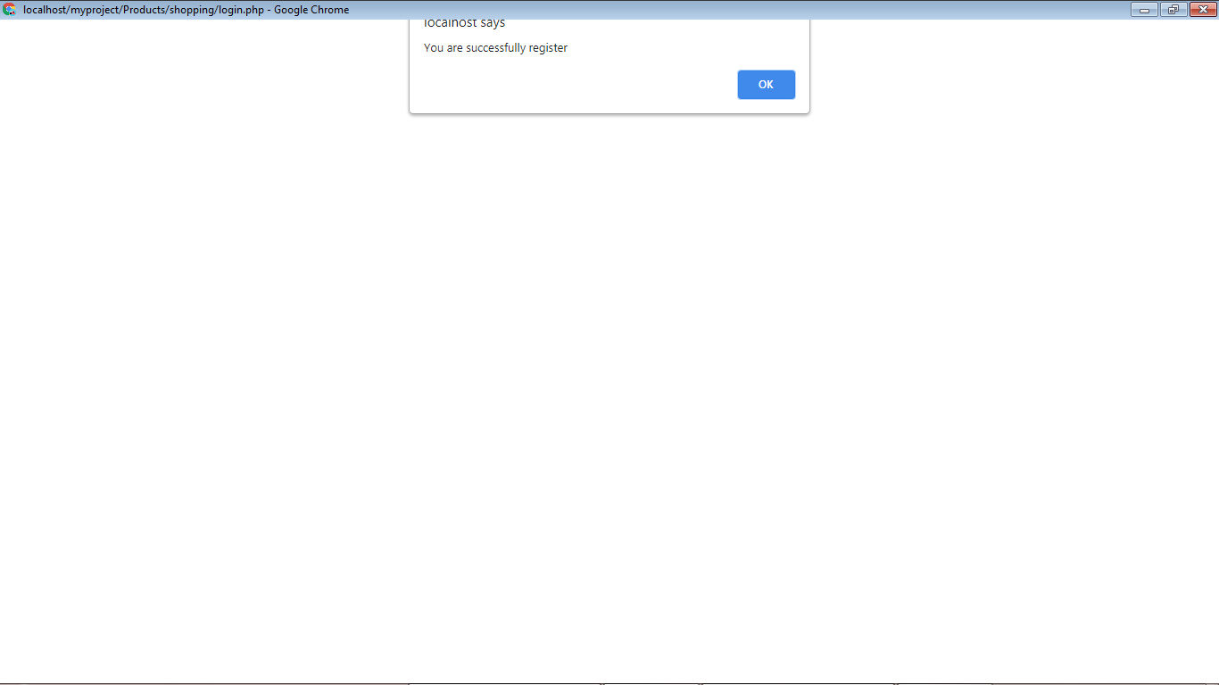

**TESTCASE FAILURE:**

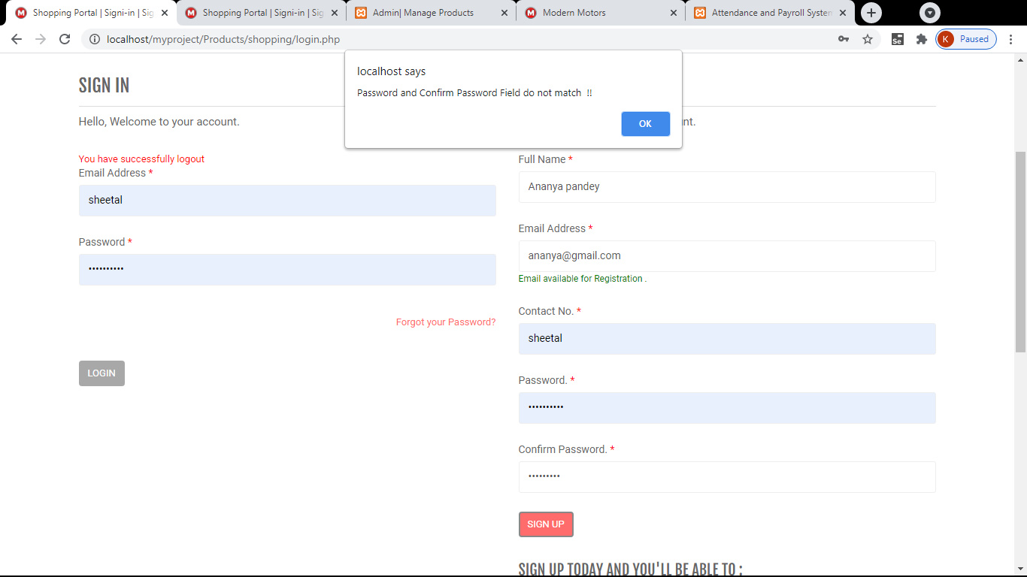

**Fig: 6.1 Unit Testing**

**6.3 Integration Testing**

Integration testing is a systematic technique for construction the program structure while at the same time conducting tests to uncover errors associated with interfacing. i.e., integration testing is the complete testing of the set of modules which makes up the product. The objective is to take untested modules and build a program structure tester should identify critical modules. Critical modules should be tested as early as possible. One approach is to wait until all the units have passed testing, and then combine them and then tested. This approach is evolved from unstructured testing of small programs. Another strategy is to construct the product in increments of tested units. A small set of modules are integrated together and tested, to which another module is added and tested in combination. And so on. The advantages of this approach are that, interface dispenses can be easily corrected.

The major error that was faced during the project is linking error. When all the modules are combined the link is not set properly with all support files. Then we checked out for interconnection and the links. Errors are localized to the new module and its intercommunications. The product development can be staged, and modules integrated in as they complete unit testing. Testing is completed when the last module is integrated and tested.

Integration testing is a systematic technique for constructing the program structure while at the same time conducting tests to uncover errors associated with. Individual modules, which are highly prone to interface errors, should not be assumed to work instantly when we put them together. The problem of course, is ―putting them together‖- interfacing. There may be the chances of data lost across on another’s sub functions, when combined may not produce the desired major function; individually acceptable impression may be magnified to unacceptable levels; global data structures can present problems.

**TABLE: 6.2 Integration Testing**

**Integration Testing**

|  |  |  |  |  |  |
| --- | --- | --- | --- | --- | --- |
| **TEST NO** | **TEST TYPE** | **TEST**  **INPUT** | **EXPECTED OUTPUT** | **ACTUAL OUTPUT** | **RESULT** |
| 1 | Integration testing | Enter new employee details | Details inserted into the record | Inserted successfully | Success |
| 2 | Integration testing | Enter new employee details | Details inserted into the record | Enter all the fields | Failure |

**TESTCASE SUCCESS:**

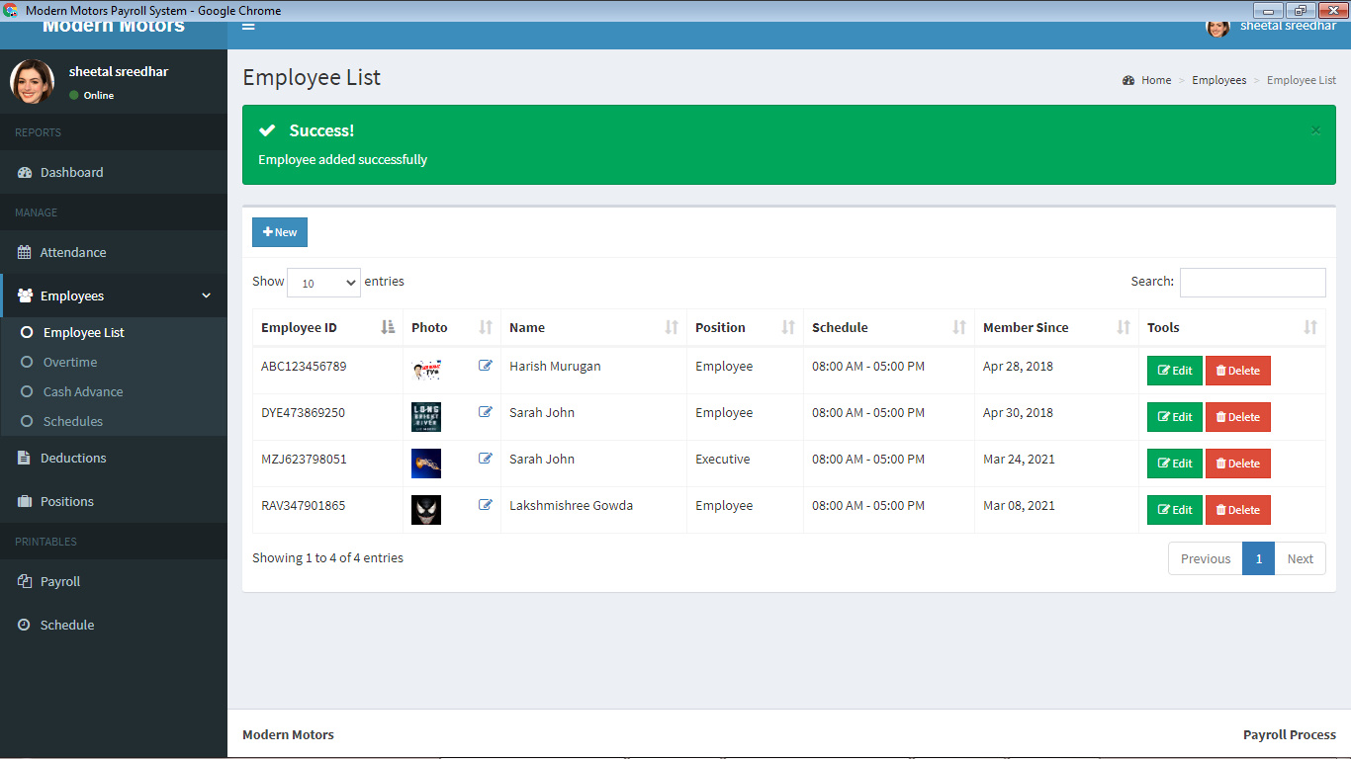

**TESTCASE FAILURE:**

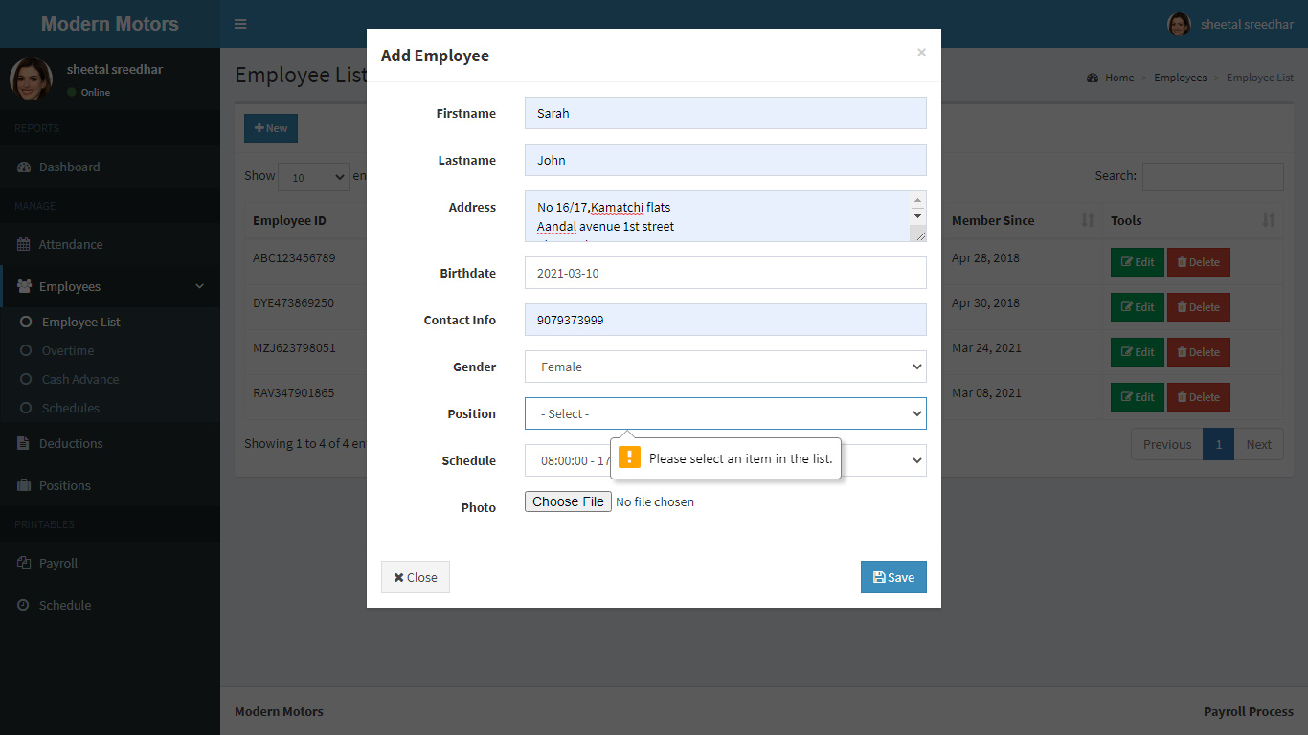

**Fig: 6.2 Integration Testing**

**6.4. Testing Techniques / Testing Strategies**

The description of behavior or functionality for the software under test may come from a formal specification, an Input/Process/Output Diagram (IPO), or a well defined set of pre and post condition. Another source for information is a requirements specification document that usually describes the functionality of the software under test and its inputs and expected outputs.

**WHITE BOX TESTING**

This testing is also called as Glass box testing. In this testing, by knowing the specific functions that a product has been design to perform test can be conducted that demonstrate each function is fully operational at the same time searching for errors in each function. It is a test case design method that uses the control structure of the procedural design to derive test cases. Basis path testing is a white box testing. White-box testing techniques are as follows:

* **Control-flow testing** - The purpose of the control-flow testing to set up a test case which covers all statements and branch conditions. The branch conditions are tested for both being true and false, so that all statements can be covered.
* **Data-flow testing** - This testing technique emphasis to cover all the data variables included in the program. It tests where the variables were declared and defined and where they were used or changed.

**BLACK BOX TESTING**

In this testing by knowing the internal operation of a product, test can be conducted to ensure, that is the internal operation performs according to specification and all internal components have been adequately exercised. It fundamentally focuses on the functional requirements of the software.

Black-box testing techniques:

* Equivalence class - The input is divided into similar classes. If one element of a class passes the test, it is assumed that all the class is passed.
* Boundary values - The input is divided into higher and lower end values. If these values pass the test, it is assumed that all values in between may pass too.
* Cause-effect graphing - In both previous methods, only one input value at a time is tested. Cause (input) – Effect (output) is a testing technique where combinations of input values are tested in a systematic way.
* Pair-wise Testing - The behavior of software depends on multiple parameters. In pairwise testing, the multiple parameters are tested pair-wise for their different values.
* State-based testing - The system changes state on provision of input. These systems are tested based on their states and input.

**6.5 Validation Testing**

Validation testing takes place after integration testing. Software is completely assembled as a package. Interfacing errors have been uncovered and corrected and a final series of software test-validation testing begins. Validation testing can be defined in many ways, but a simple definition is that validation succeeds when the software functions in manner that is reasonably expected by the customer. Software validation is achieved through a series of black box tests that demonstrate conformity with requirement.

After validation test has been conducted, one of two conditions exists.

* The function or performance characteristics confirm to specifications and are accepted.
* A validation from specification is uncovered and a deficiency created.

Deviation or errors discovered at this step in this project is corrected prior to completion of the project with the help of the user by negotiating to establish a method for resolving deficiencies. Thus the proposed system under consideration has been tested by using validation testing and found to be working satisfactorily. Though there were deficiencies in the system they were not catastrophic. The process of evaluating software during the development process or at the end of the development process to determine whether it satisfies specified business requirements. Validation Testing ensures that the product actually meets the client's needs.

**TABLE: 6.3 Validation Testing**

**Validation Testing**

|  |  |  |  |  |  |  |  |  |  |  |  |
| --- | --- | --- | --- | --- | --- | --- | --- | --- | --- | --- | --- |
| |  |  |  |  |  |  | | --- | --- | --- | --- | --- | --- | | **TESTNO** |  |  |  |  |  | | **TEST TYPE** | **TEST INPUT** | **EXPECTED OUTPUT** | **ACTUAL OUTPUT** | **RESULT** |
| **1** | Validation testing | Enter the username and password | Allowed any username and password if it not satisfies the constraint | Invalid  login | Failure |
| **2** | Validation testing | Enter the username and password | Allowed any username and password if it satisfies the constraint | Login successfully | Success |

**TESTCASE FAILURE:**

### C:\Users\rajaprabu\Documents\Bandicam\bandicam 2021-03-24 12-25-08-025.jpg

**TESTCASE SUCCESS:**

### C:\Users\rajaprabu\Documents\Bandicam\bandicam 2021-03-24 13-26-16-194.jpg

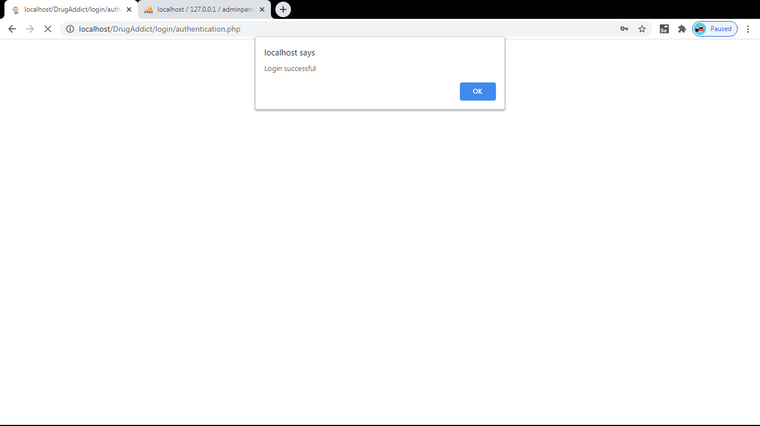

**Fig: 6.3 Validation Testing**

# 

# 

# 

# 

# CHAPTER - VII

**SYSTEM IMPLEMENTATION**

**7.1 Introduction**

System Implementation is the process of bringing developed system into operational use. If the implementation phase is not carefully planned and controlled, it can be lead to many critical problems. Thus proper implementation is essential to provide a reliable system to meet managerial requirements. Implementation is one of the most important tasks in project. Implementation is the phase, in which one has to be cautions, because all the efforts undertaken during the project will be fruitful only if the tool is properly implemented according to the plans made. The implementation phase is less creative than system design. It is primarily concerned with user training; site preparation and file-sites, the test of the network along with the system are also included under implementation. Depending on the nature of the system extensive user training maybe required programming is itself a design works. The initial parameters of the management information system should be modified as a result of programming efforts. Programming provides a real test for the assumption made by the analyst.

Implementation is used here to mean the process of converting a new or revised system into an operation one. Here the new system is implemented to an operational use. Maintenance is far more than fixing mistakes. The maintenance can be defined using four activities that are undertaken after a program is released for use.

The second activities that contribute to a definition of maintenance occurs because of the rapid change that encountered in every aspect of computing. Adaptive maintenance – as activity that modifies software to properly interface with a changing environment – is both necessary and common place.

The third activity that may be applied to definition of maintenance occurs when software package is successful. As the software is used new recommendations for new capabilities, modifications to existing function and general enhancements are received from the user, to satisfy this request perceptive maintenance is used.

The fourth maintenance activity occurs when software is changed to improve future maintainability or reliability, or to provide a better basic for future enhancements. This is often called preventive maintenance, which is characterized by reverse engineering and re-engineering technique.

**7.2 Implementation**

The system has been tested in the location of the developer. But it is not possible to find all errors here. It may be that even after through testing the user will find errors. In such a case the user when reports the errors it is possible to correct those errors as that coding has been documents and it is possible to find out the location where the error is occurring and the reason for error can be analyzed and corrected. This developed system supports for corrective maintenance.

As this software can be run with the requirements given above and it does not involve any particular hardware as such and it can be run with the rapid development that is being encountered in the computer industry.

If there is a need to include any new modules then it has been externally and then includes to it with the exits architecture. But up to now the system holds all the possible reports generation tools, which a team needs. Later on it correspondence with this limitation may upgrade the system.

**CHAPTER - VIII**

**PERFORMANCE AND LIMITATIONS**

**8.1. Performance**

This application provides greater efficiency to the customers so that they can enhance the features in the application. This website contains better compatibility and security which will be user friendly to the customers. This application provides reduced cost to the customers. It is also time consuming. The employees will deal with the customers in easy and a comfortable manner. Users information will be maintained in a securable port.

**8.2. Limitations Of The System**

* Appropriate tracking is not available in the website for purchased order and services .
* There is no applicable customer care service for the customers.
* There is no OTP generation for sending SMS to the customers.

**8.3 Future Enhancements**

* Tracking for purchased order or service with courier delivery details will be available in the website.
* There will be a proper customer care service for the customers in case of any queries.
* In future there will be OTP generations to send SMS to the customers about the payment and order details.

CHAPTER – IX

APPENDICES

**9.1. Sample Screens and Reports**

**HOME PAGE:**



**Fig. 9.1 Home Page**

**CUSTOMER SIGNIN AND SIGNUP PAGE:**

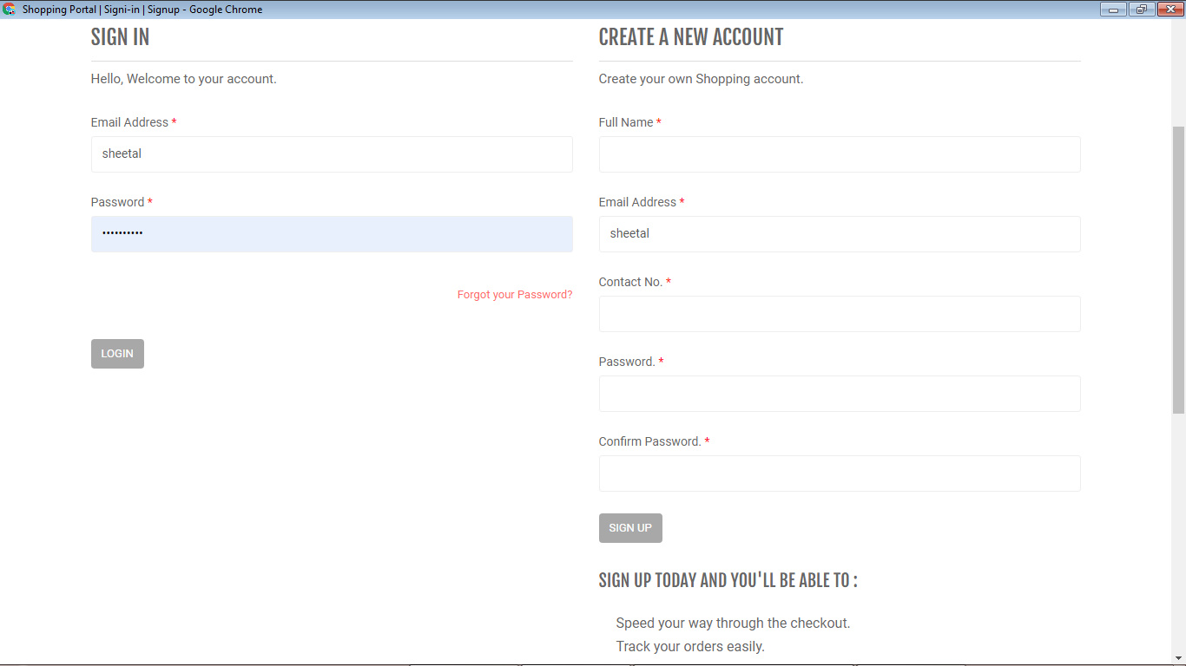

**Fig. 9.2 Customer Signin and Signup Page**

**SHOPPING CART PRODUCT PAGE:**

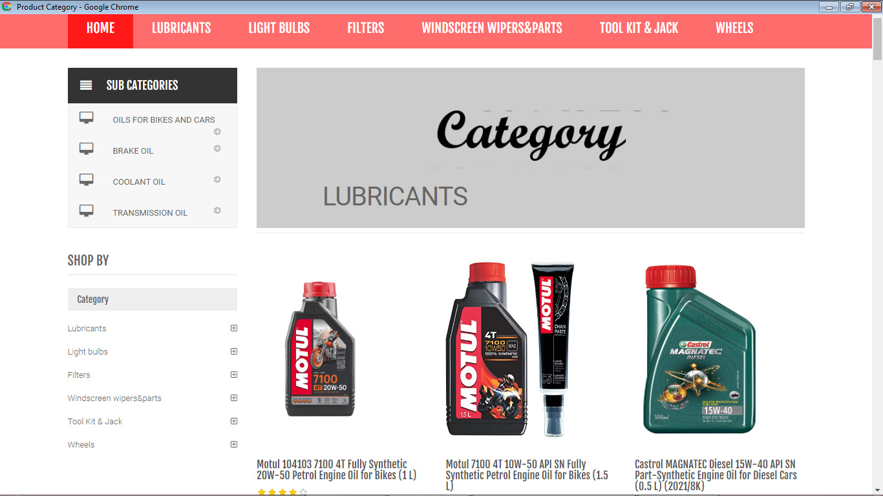

**Fig. 9.3 Shopping Cart Product Page**

**SHOPPING CART SERVICE PAGE:**

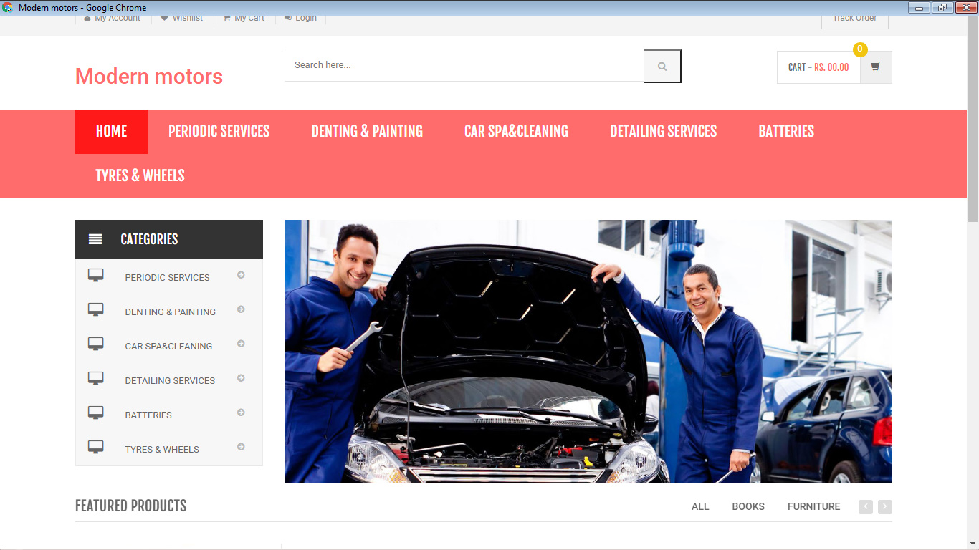

**Fig. 9.4 Shopping Cart Service Page**

**CATEGORY PAGE:**

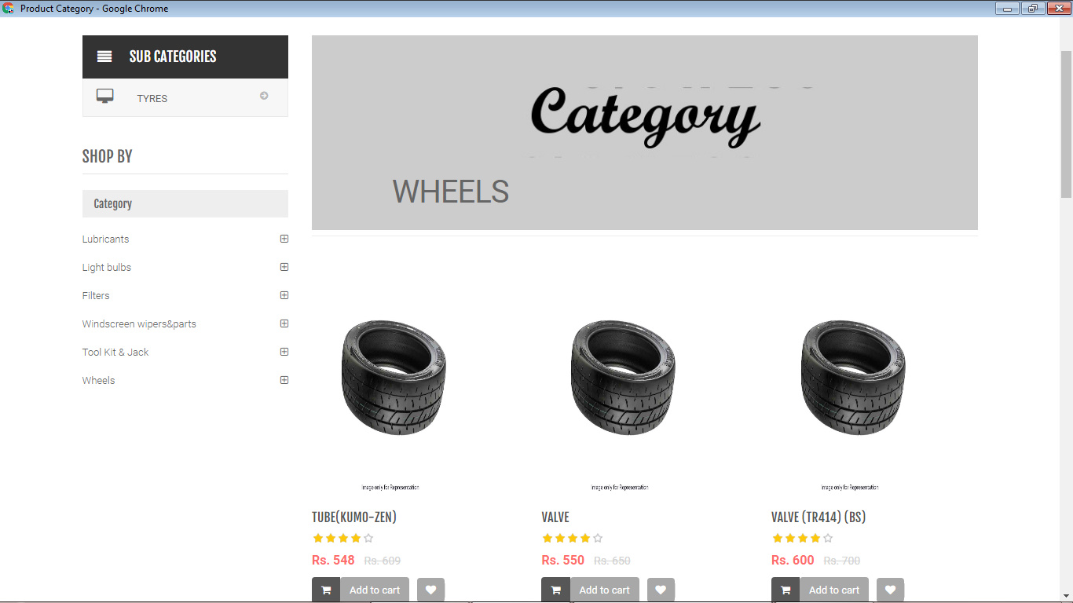

**Fig. 9.5 Category Page**

**SUBCATEGORY PAGE:**

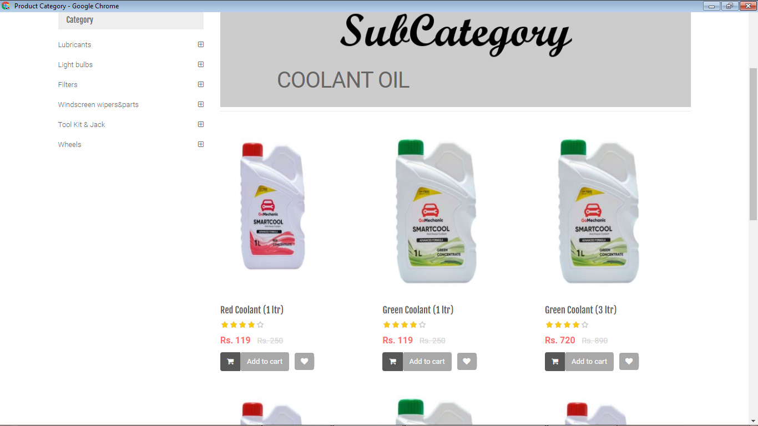

**Fig. 9.6 Subcategory Page**

**MY CART PAGE:**

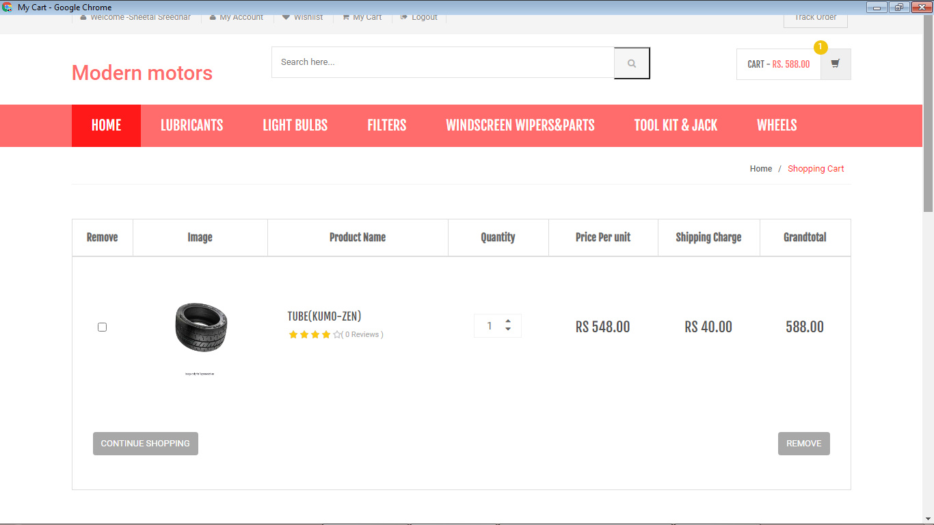

**Fig. 9.7 My Cart Page**

**ORDER DETAILS PAGE:**

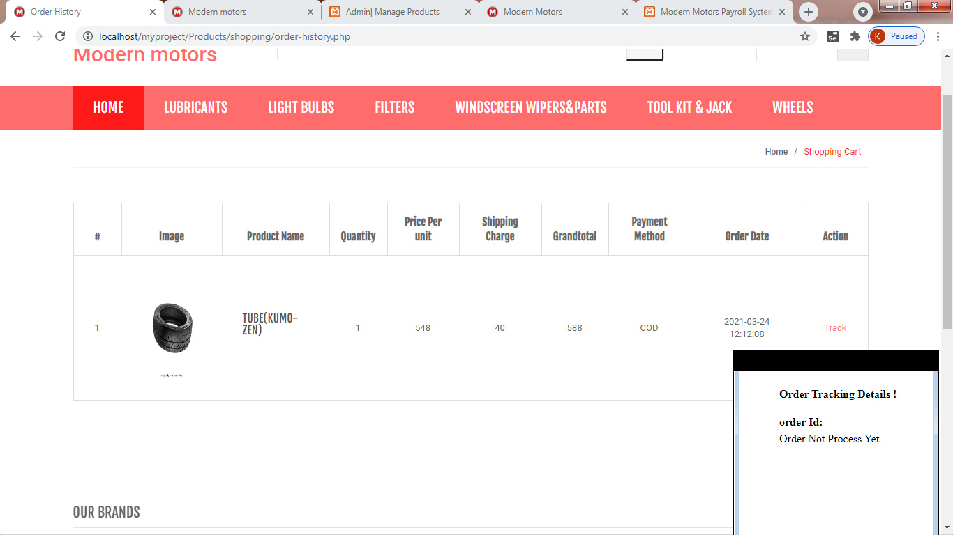

**Fig. 9.8 Order details Page**

**EMPLOYEE LIST PAGE:**

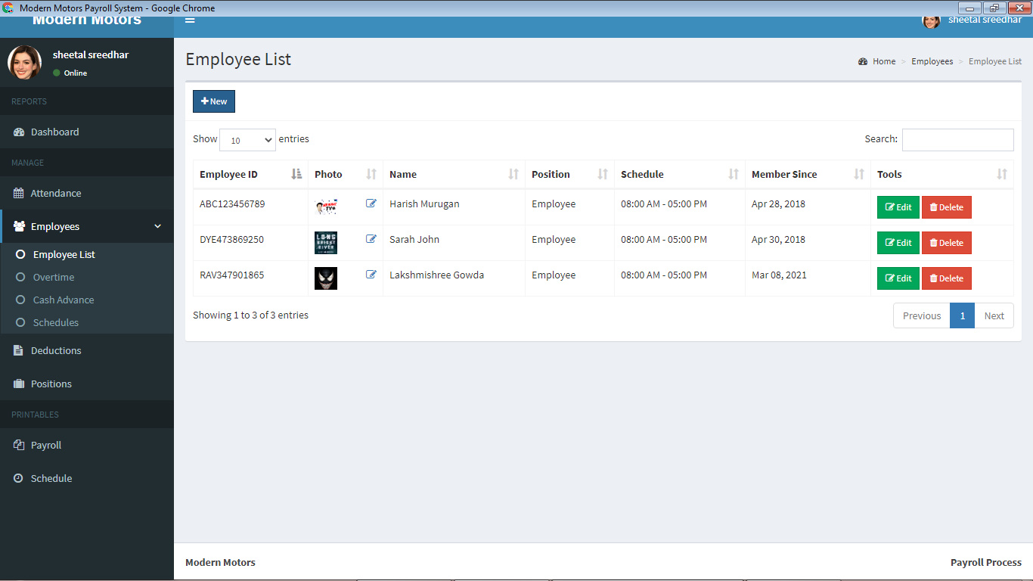

**Fig.9.9 Pay Employee list Page**

**CASH ADVANCE PAGE:**

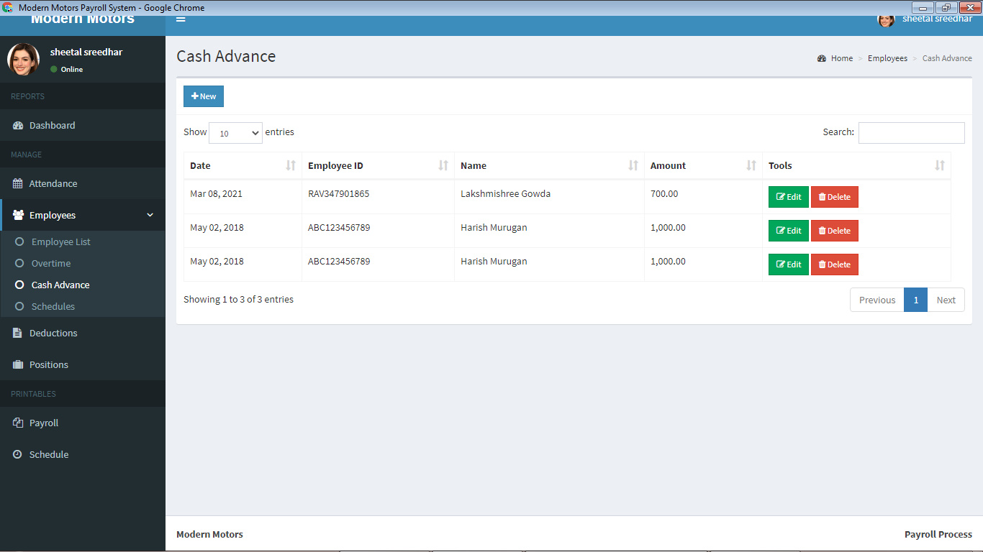

**Fig.9.10 Cash advance Page**

**DEDUCTION PAGE:**

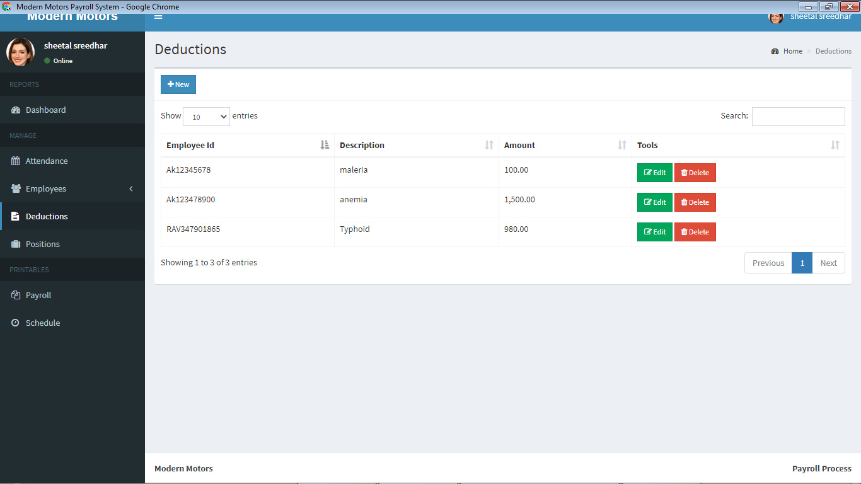

**Fig.9.11 Deduction Page**

**PAYROLL PAGE:**

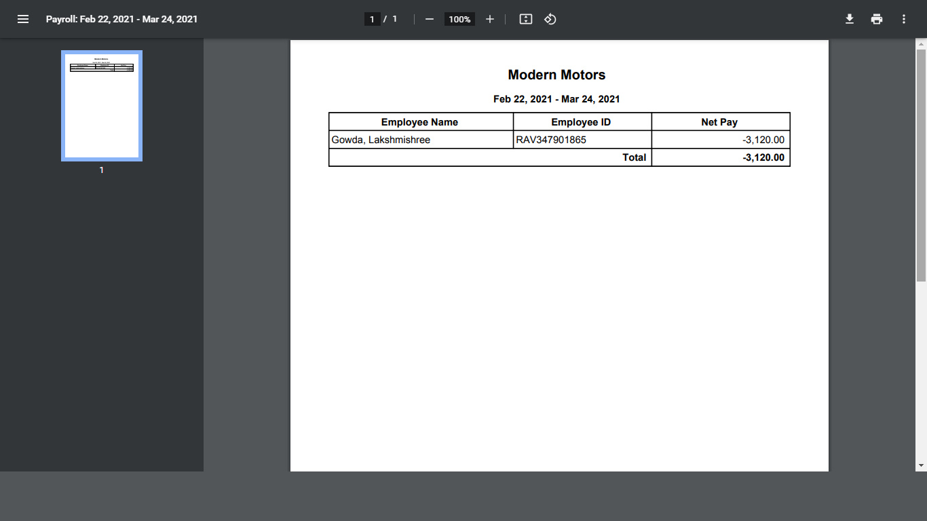

**Fig.9.12 Payroll Page**

**PAYSLIP PAGE:**

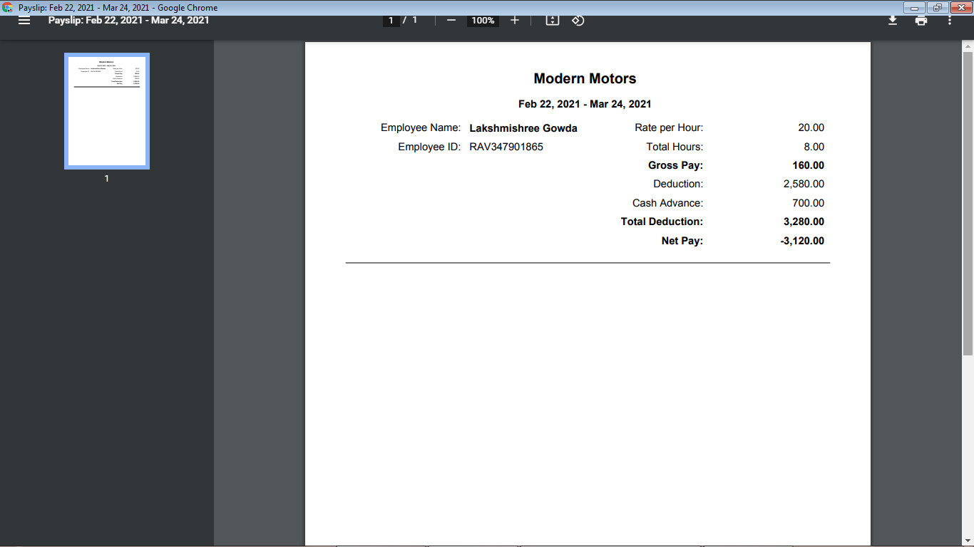

**Fig.9.13 Payslip page**

**TIMEIN AND TIMEOUT OF EMPLOYEE PAGE:**

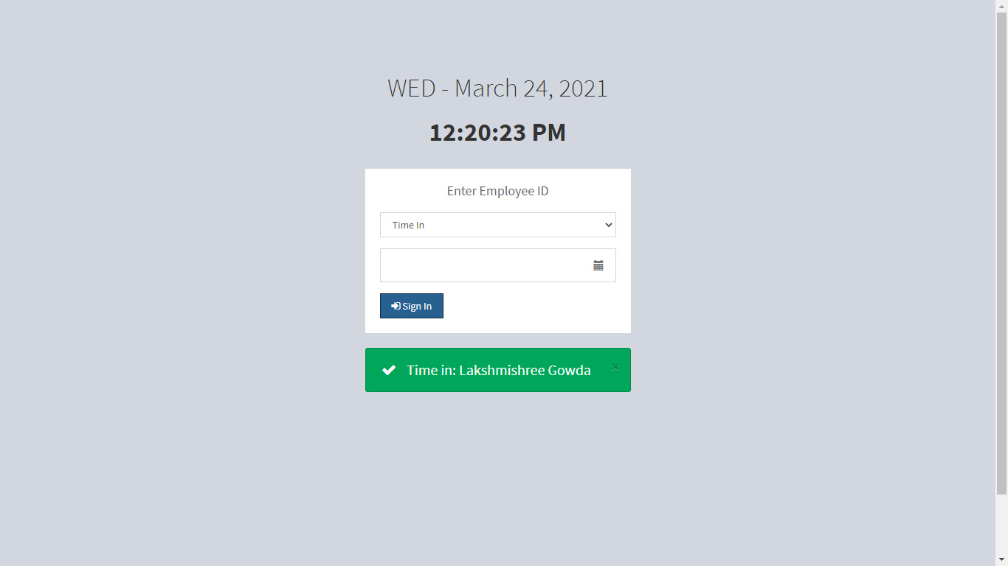

**Fig.9.14 Time in and Time out page**

**ADMIN SIDE FOR INSERTING PRODUCTS AND SERVICES:**

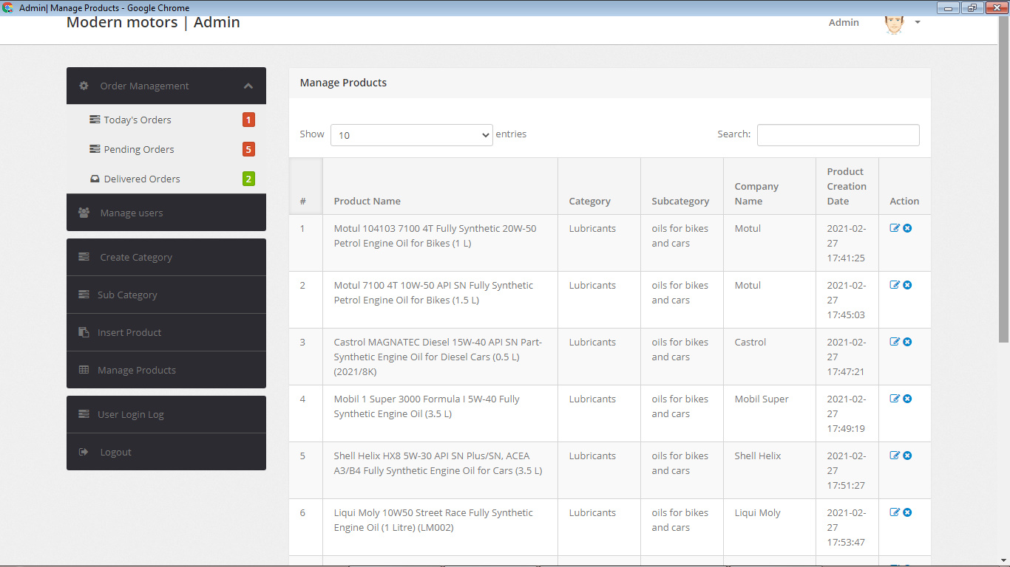

**Fig.9.15 Admin page**

**PAYMENT PAGE:**

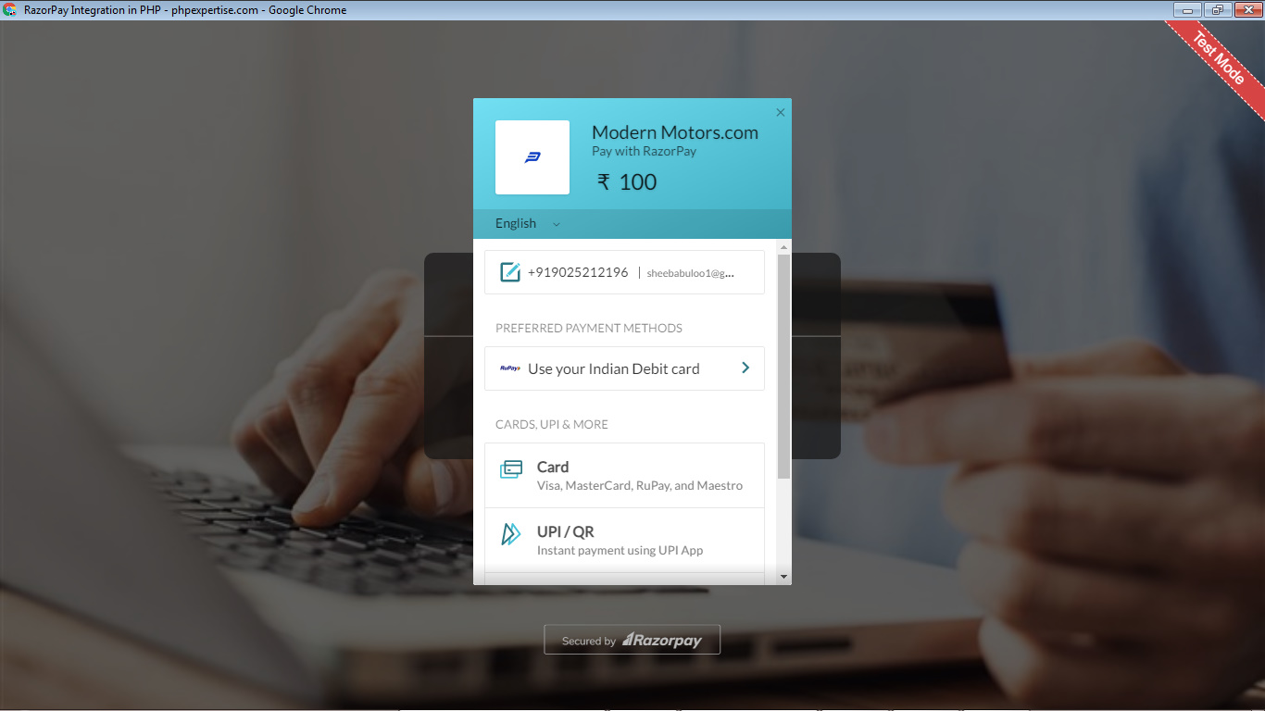

**Fig.9.16 Pay With RazorPay Page**

**9.3 Conclusion**

This project “**Modern Motors Service and Payroll Management System”** completed by satisfying the required design specifications. The system provides user-friendly interface which was developed with modular approach. All modules in the system have been tested with valid data and invalid data and all modules working successfully. Thus the system has fulfilled all the objectives identified and is able to replace the existing system. The constraints are met and overcome successfully. The system designed as like it was decided in the design phase. This software has user-friendly screen that enables the user to use without any inconvenience. This would help the patients to easily interact with the system.

CHAPTER-X

REFERENCES

Book Reference

* The Joy of PHP Programming: A Beginner's Guide – by Alan Forbes. ...
* PHP & MySQL Novice to Ninja – by Kevin Yank. ...
* Head First PHP & MySQL – by Lynn Beighley & Michael Morrison. ...
* Learning PHP, MySQL, JavaScript, and CSS: A Step-by-Step Guide to Creating Dynamic Websites – by Robin Nixon.

**Web Reference**

* [www.w3schools.com](http://www.w3schools.com/)
* [www.mysql.com](http://www.mysql.com/)
* [www.webreference.com](http://www.webreference.com/)
* [www.tutorialpoint.com](http://www.tutorialpoint.com/)
* [www.phpmyadmin.com](http://www.phpmyadmin.com/)